Contents

61. AEM project structure and importing project in Eclipse IDE 2

62. Synchronising Eclipse IDE with local AEM instance 7

63. Debugging AEM application in Eclipse IDE 11

64. Content Fragment 13

65. Create Content Fragment and its variation 14

66. Adding an image in Content Fragment 15

67. Content Fragment Model 16

68. Dynamic dropdown with DataSource 17

69. Understanding Editable Template 26

70. Creating Editable Template 28

# 61. AEM project structure and importing project in Eclipse IDE

Below is the Project structure of our **Demo Training** AEM project.

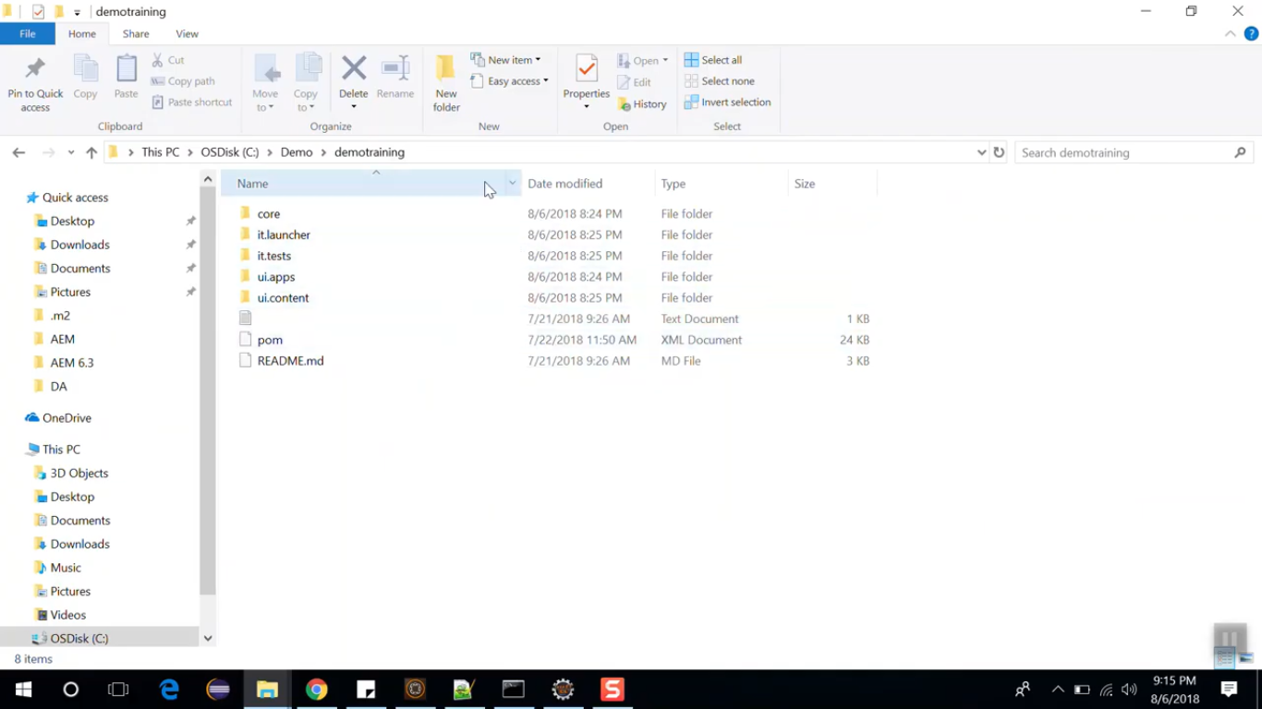

|  |  |
| --- | --- |
| **Folder Name** | **Description** |
| core | It includes all the java code and deploy to AEM as OSGI bundle. |
| it.launcher | contains code that deploys it.tests bundle to the servers and triggers remote Junit execution. |
| it.tests | J Unit tests which are executed server side |
| ui.apps | apps part of the project |
| ui.content | content and configurations of the project |
| POM.xml | project configuration file. |

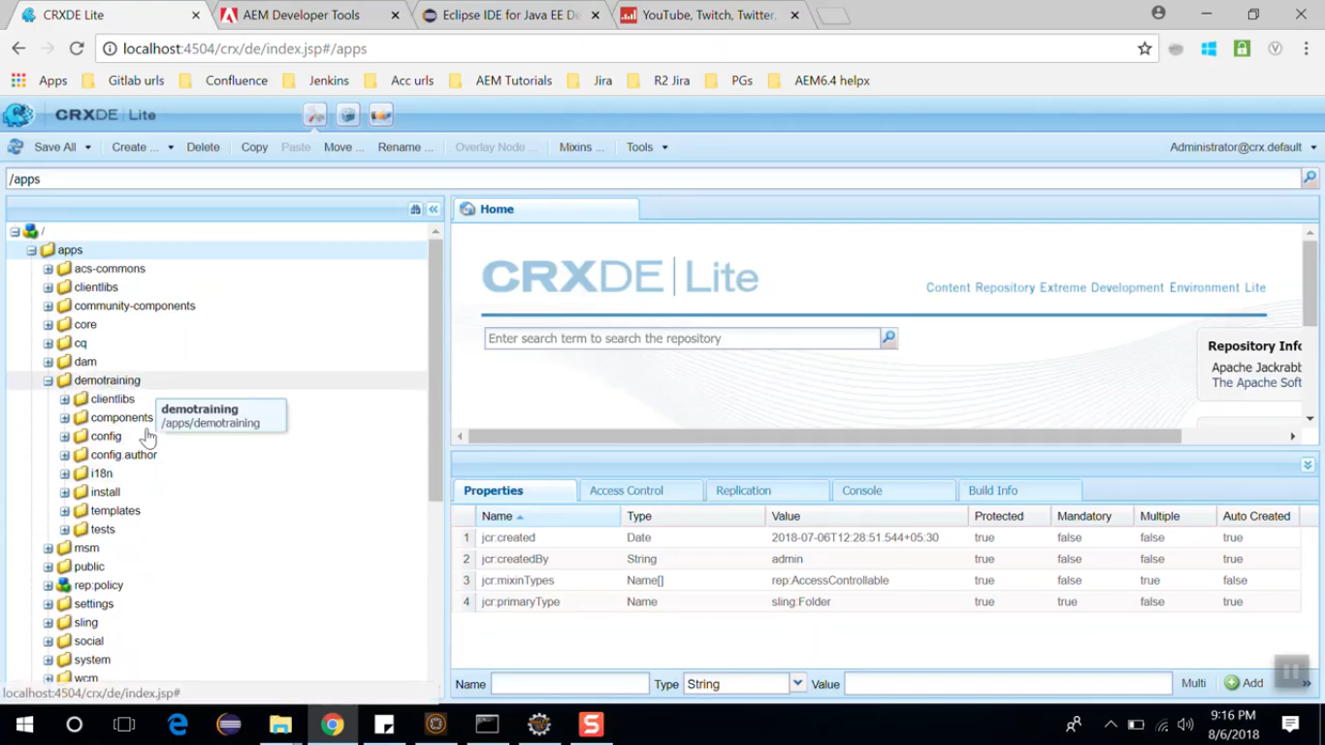 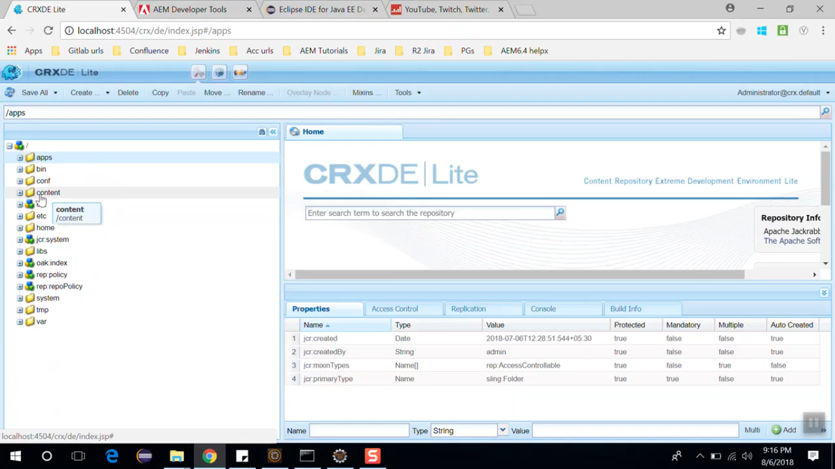

Figure - ui.apps folder Figure - ui.content folder

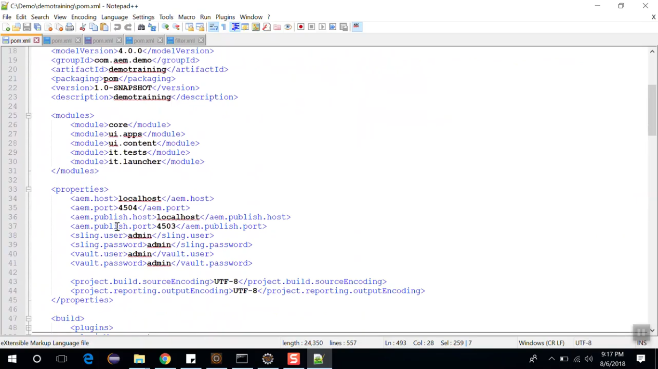

In above POM.xml, you can see all the modules and the global properties which are setup to deploy the local AEM instance. These properties can be overridden via command line when deploying to higher environments.

POM.xml also includes dependency management section. It lists all the dependencies and all the versions API to be used in the project.

One of the key dependency is uber.jar file. This is special JAR provided by Adobe which includes all the AEM API structures – single dependency entry for the version of AEM

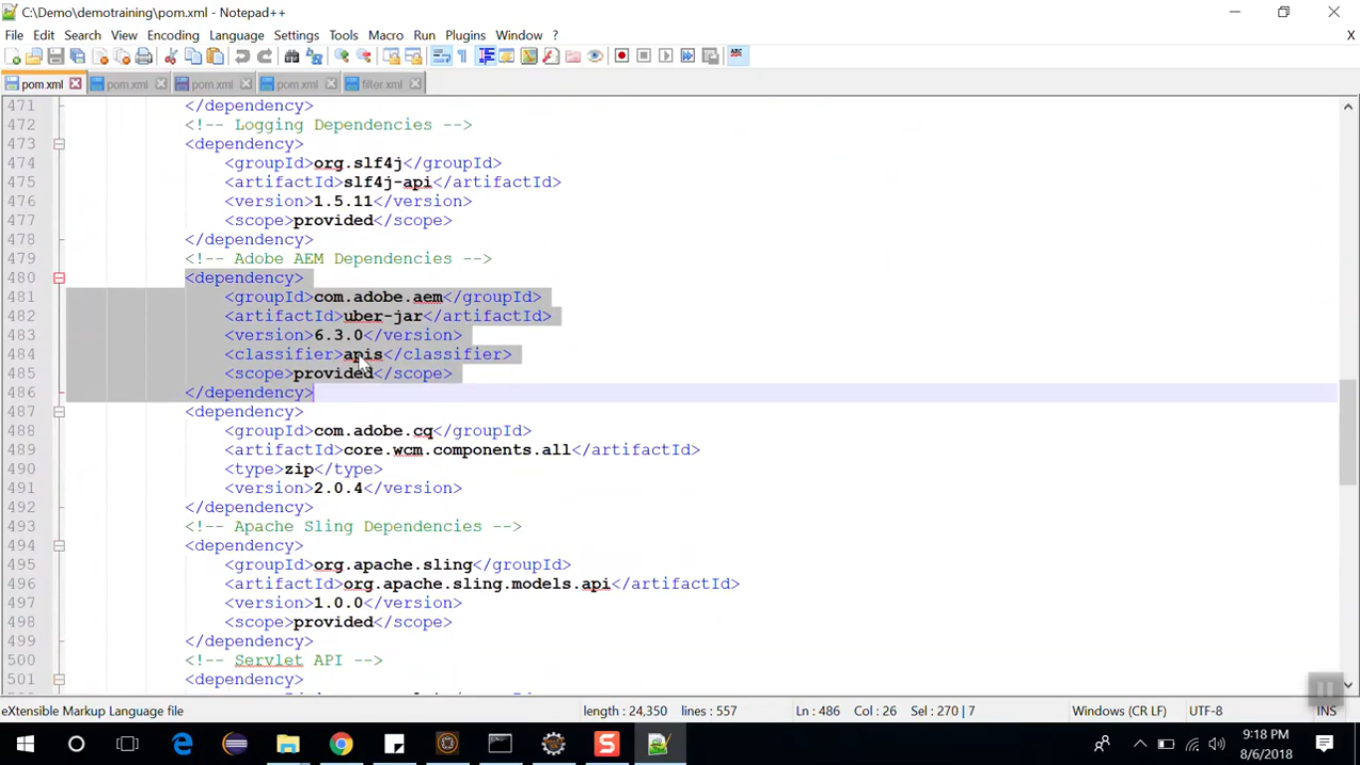

Open **core** folder of our project **C:/Demo/demotraining/core**. Open **POM.xml** from this folder.

You will see **maven-bundle-plugin** (image) which is responsible for compiling java code into an OSGI bundle that can be recognised by OSGI container.

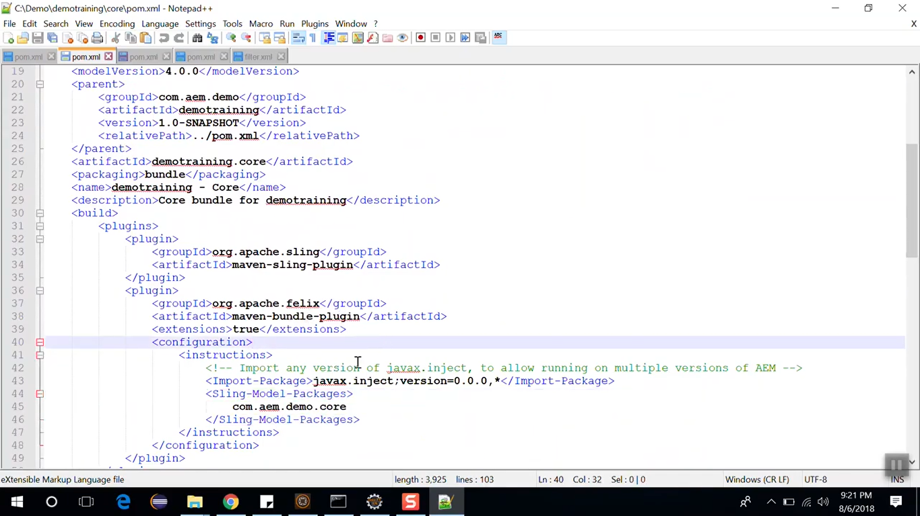

So, when we install our project, 1 bundle gets created. To see that bundle, go to system console.

<http://localhost:4504/system/console/bundles>. See the highlighted created bundle with cursor pointer.

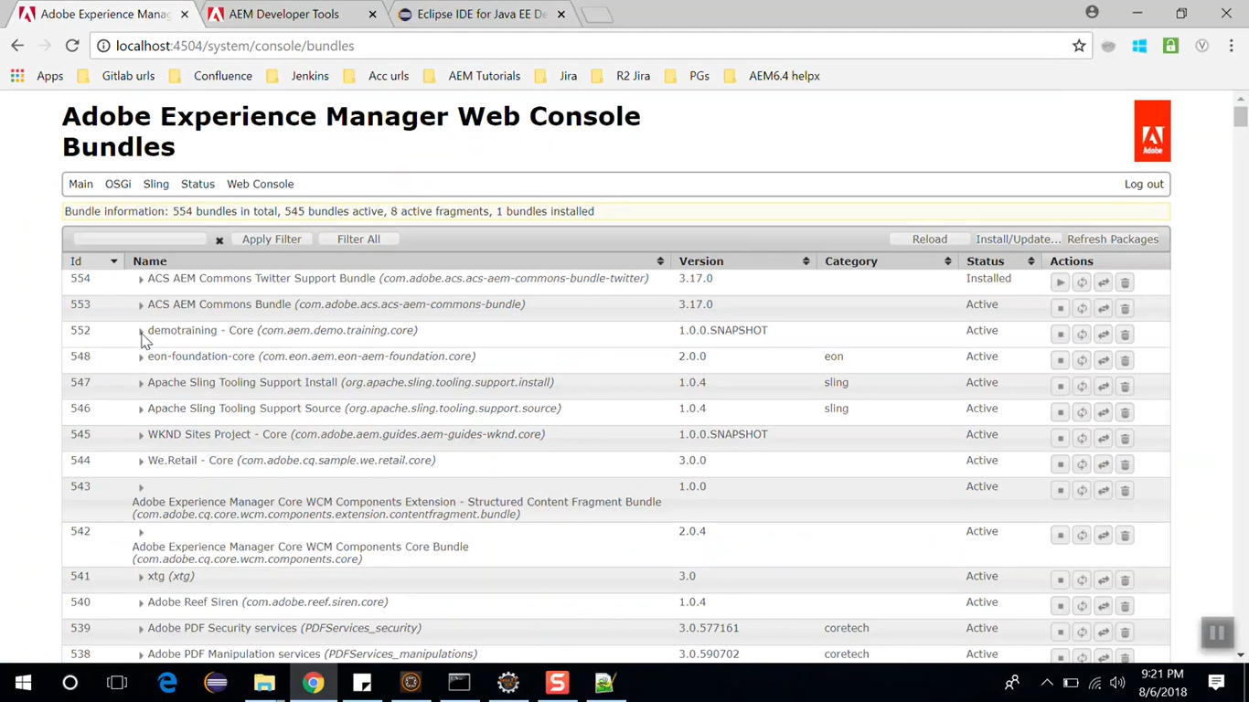

There is one more plugin called **maven-sling-plugin** which allows the core bundle to be deployed to AEM.

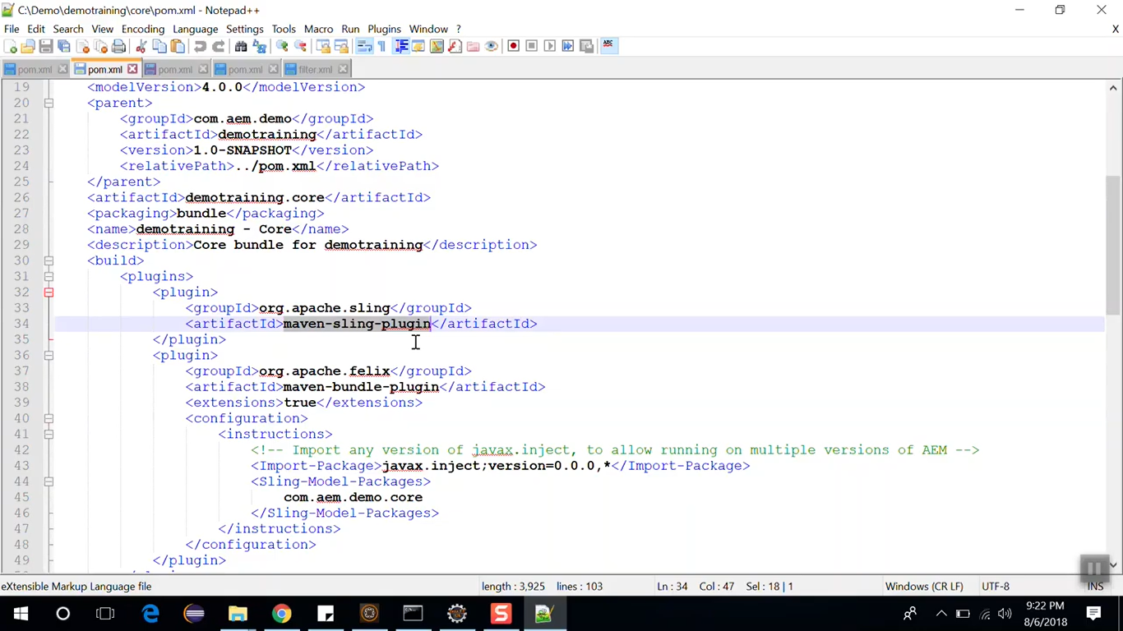

Open CRX/DE. Go to node **/apps/demotraining/install/demotraining.core-1.0-SNAPSHOT.jar**

That bundle is a JAR file which you can locate here which allows core bundle to be deployed to AEM.

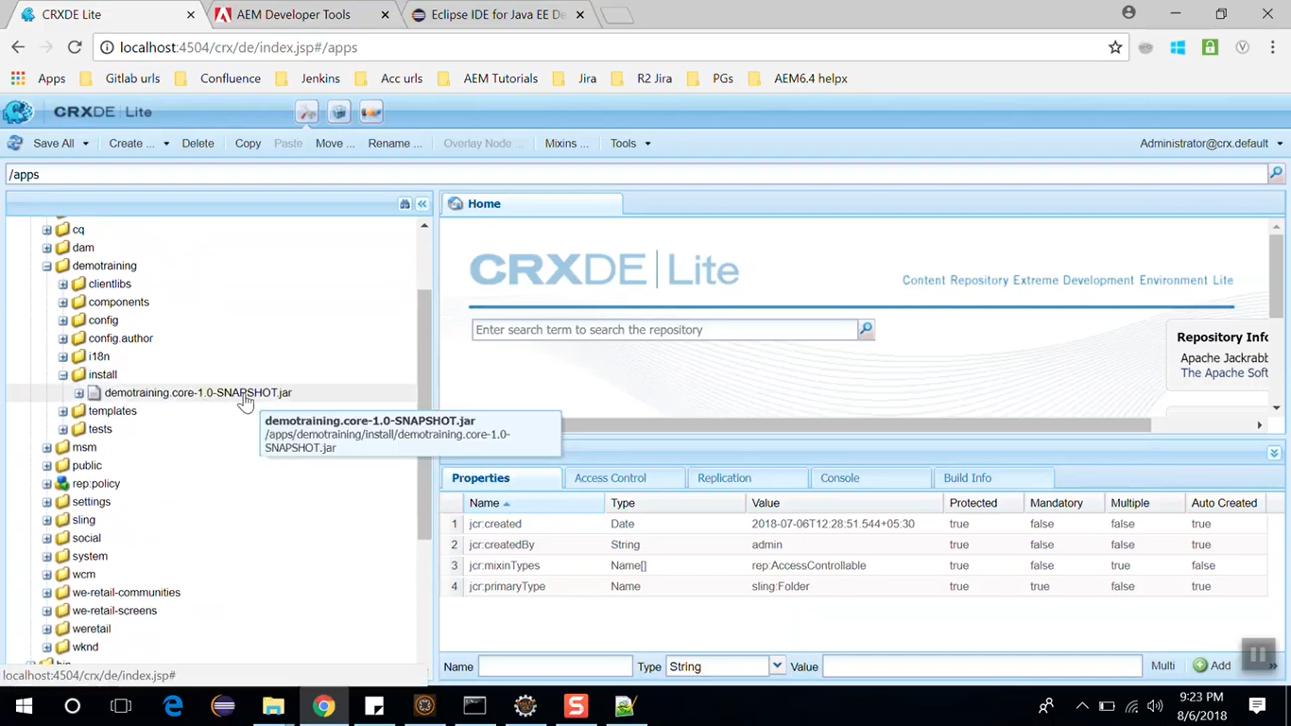

Open **ui.apps** folder of our project **C:/Demo/demotraining/ui.apps**. Open **POM.xml** from this folder.

You will see **content-package-maven-plugin** (image) which is responsible for compiling the contents of UI apps module into an AEM package that can be deployed to the AEM.

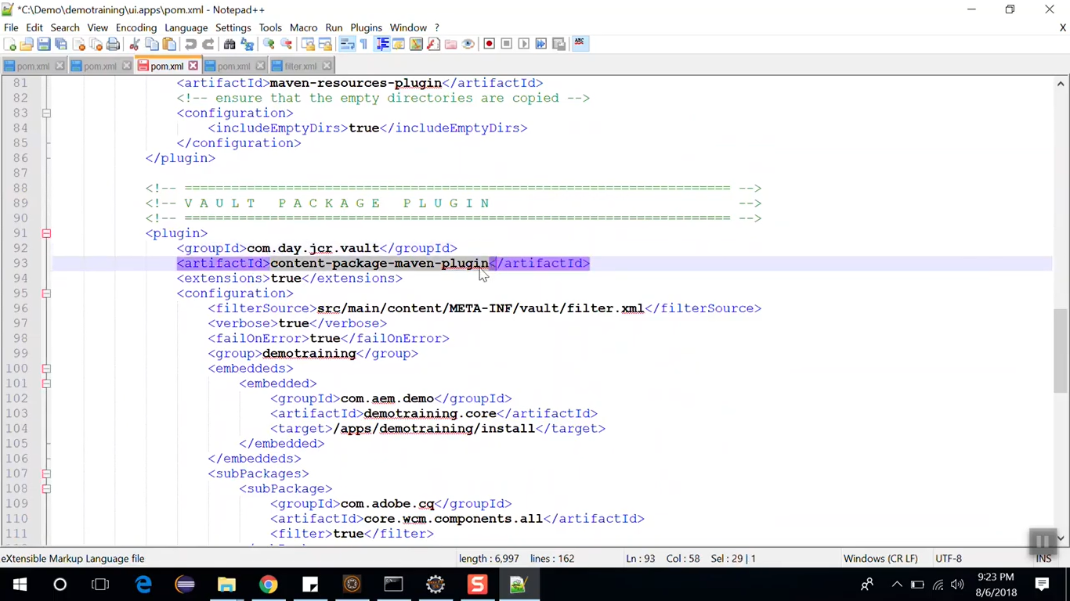

You can see various packages in Package Manager. These packages have been deployed in AEM because of this plugin **content-package-maven-plugin.**

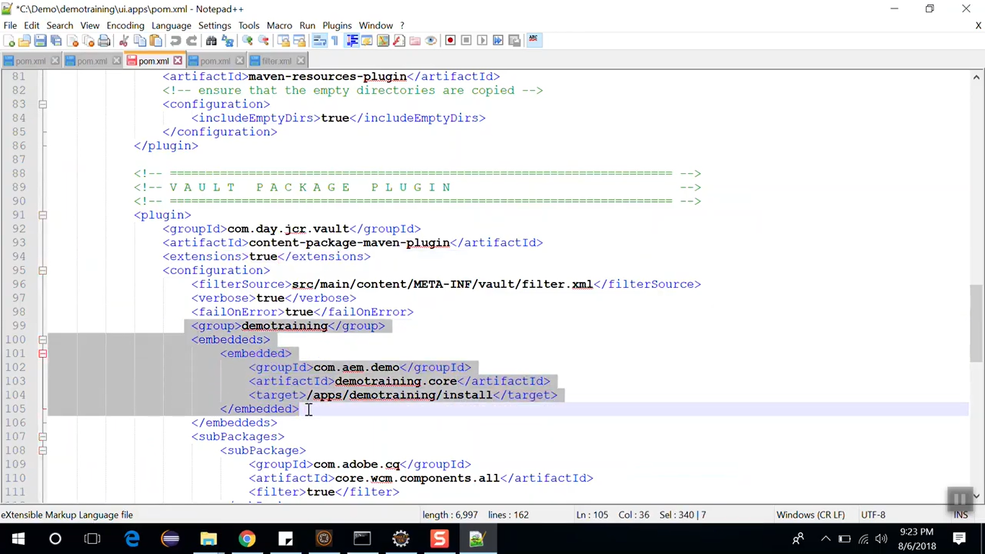

The above **embedded** tags include compile core bundle as part of ui.apps package and it will tell where it will get installed as mentioned in **target** tag i.e. **/apps/demotraining/install**.

As highlighted (below image), **core.wcm.components.all** is included as sub-package. This will deploy core component package along with demo code each time.

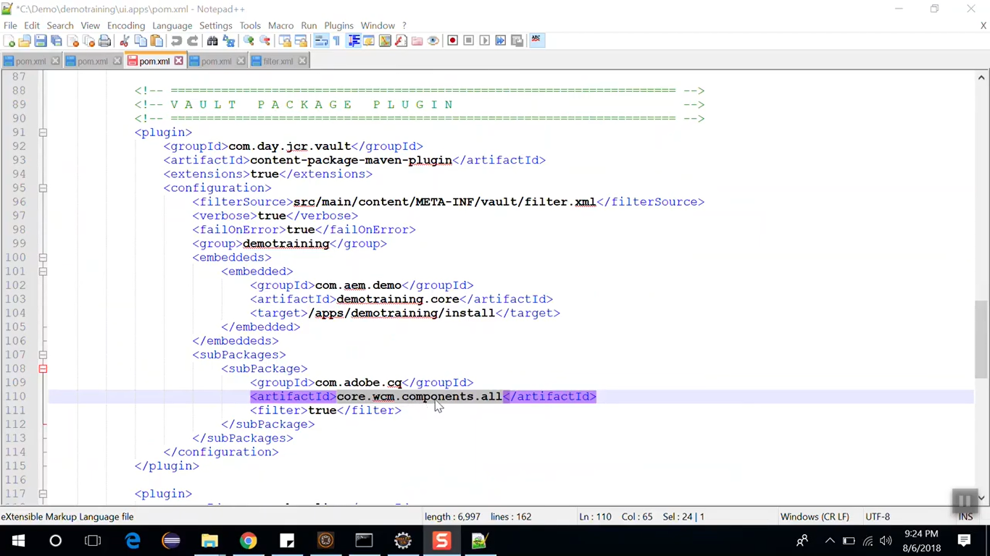

Open **ui.content** folder of our project **C:/Demo/demotraining/ui.content**. Then go to path **C:/Demo/demotraining/ui.content/src/main/content/META-INF/vault**. Open f**ilter.xml** from this folder.

This file defines list of paths which are packaged and deployed to AEM.

Now we will see how to import this file in Eclipse IDE.

Download and install **Eclipse IDE Oxygen version**.

To Download and install **AEM Developers Tool** in **Eclipse IDE** perform below steps:

Open Eclipse IDE --> Click **Help** menu --> select **Install New Software** option.

Click on **Add** button on **Install** dialog box.

Enter **AEM Developers Tool** in **Name** field of **Add Repository** dialog box.

Enter <https://eclipse.adobe.com/aem/dev-tools/> in **Location** field of **Add Repository** dialog box.

Click on **OK** button in **Add Repository** dialog box and then click on **Finish** button on **Install** dialog box.

Restart Eclipse IDE. This way you can Install **AEM Developer Tools.**

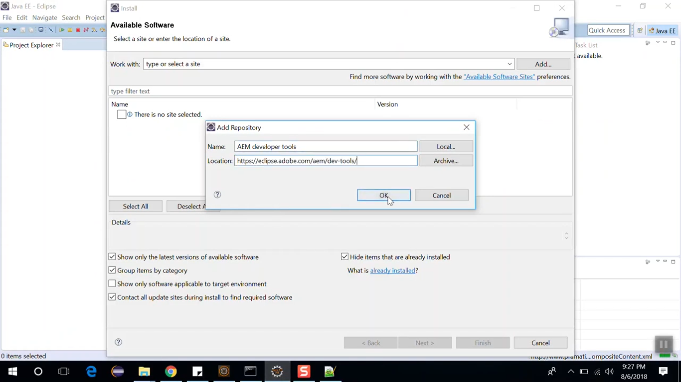

Now let’s **import** our **Demo project**.

Click on **Files menu**, select **Import** option. Select **Maven** --> Select **Existing Maven Projects** -->

select projects folder path as **root directory** --> select **all POM files** --> Click on **Finish** button.

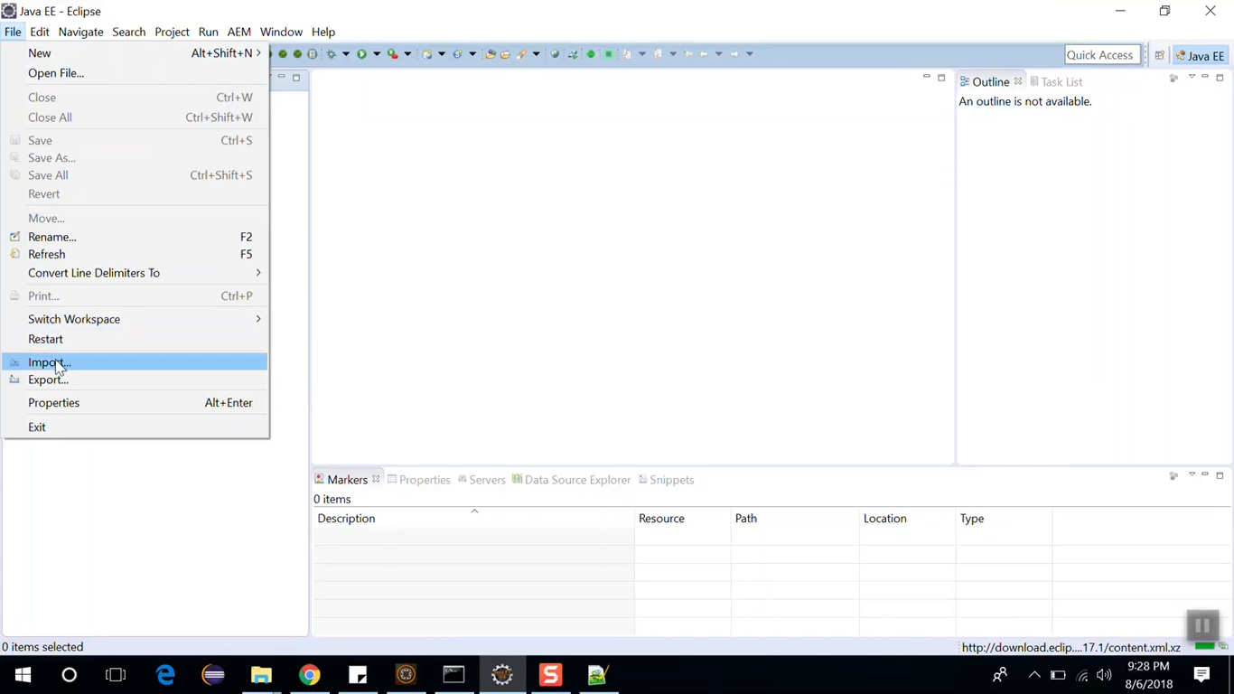 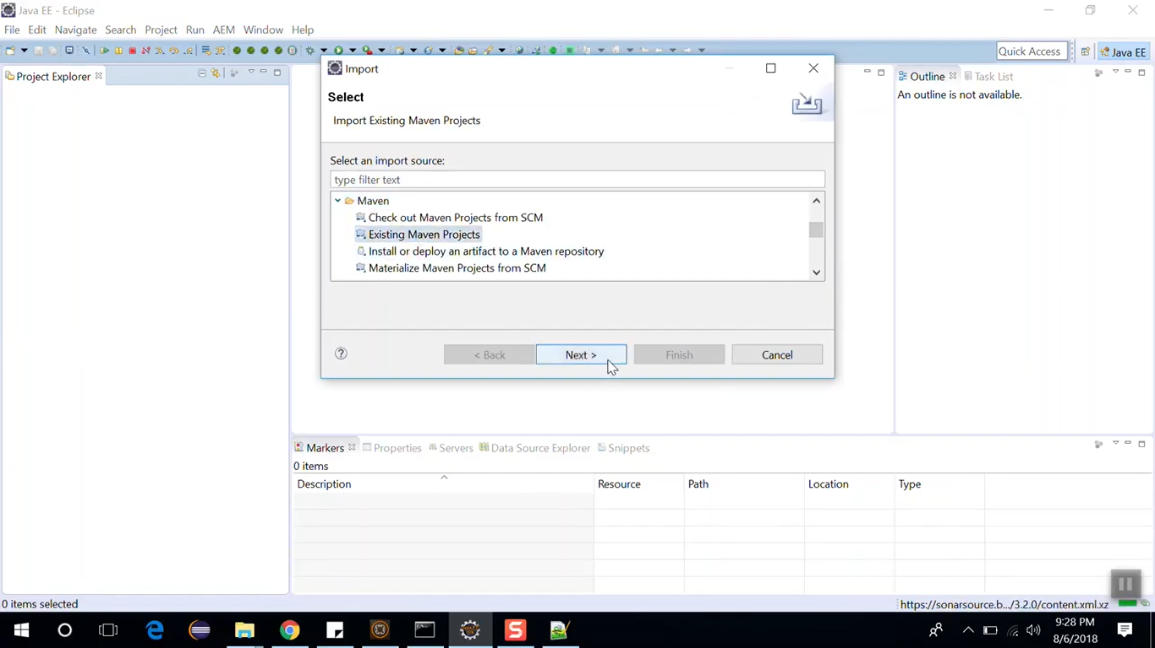

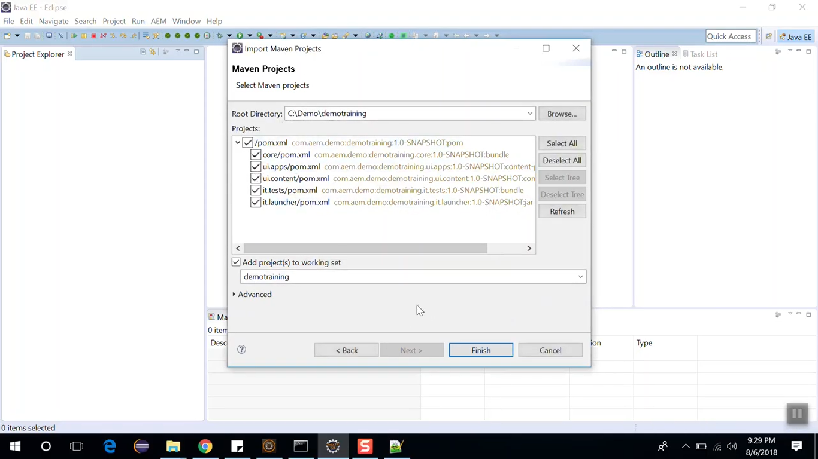

# 62. Synchronising Eclipse IDE with local AEM instance

We have already imported our AEM application in Eclipse IDE in last section.

We must change the Eclipse’s perspective from Java EE to AEM.

To do so, click on the icon shown in the below image.

In **Open Perspective** dialog box, select AEM and click on **OK** button.

This way you can switch from **Java EE** perspective to **AEM** perspective.

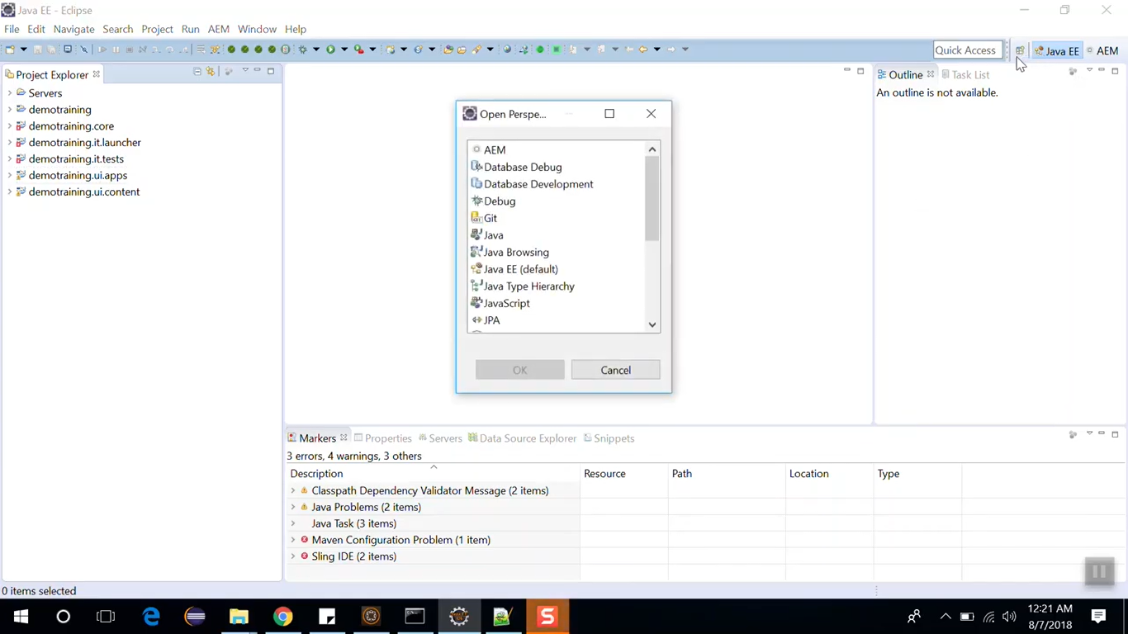

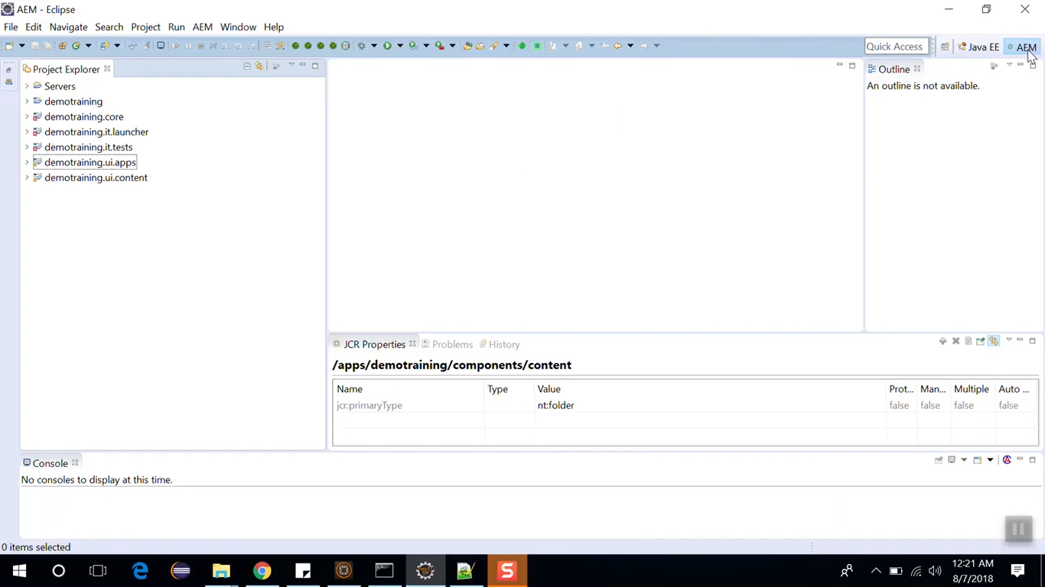

Click on link in **Servers explorer** as shown in below image to create new server.

Set **Server’s Host Name** as **AEM localhost** in **New Server** dialog box. Click on **Next** button.

Select all resources (JAR files) and click on **Finish** button.

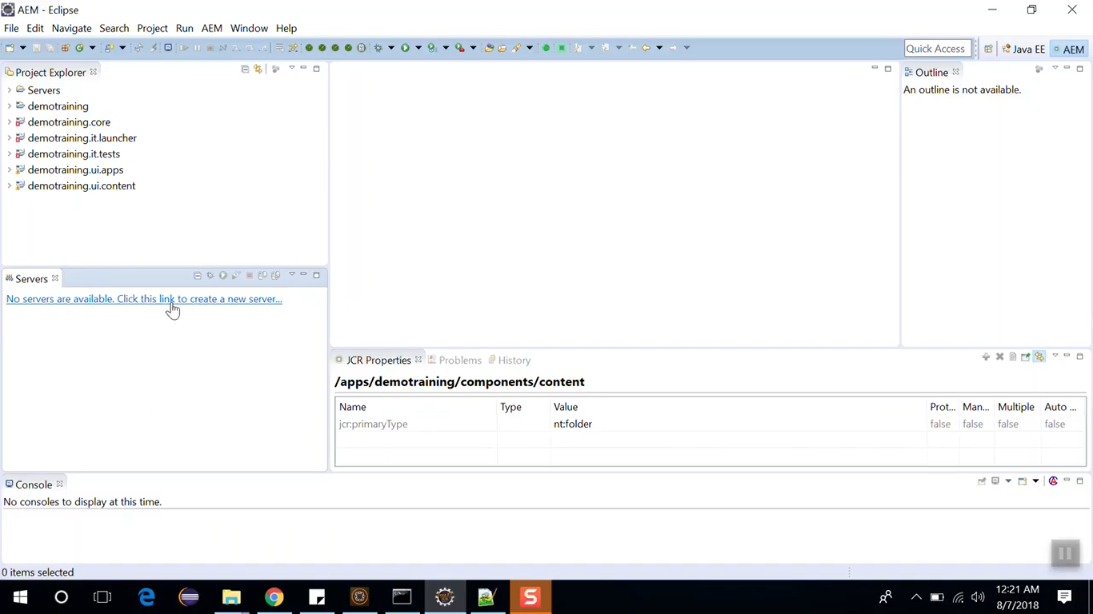

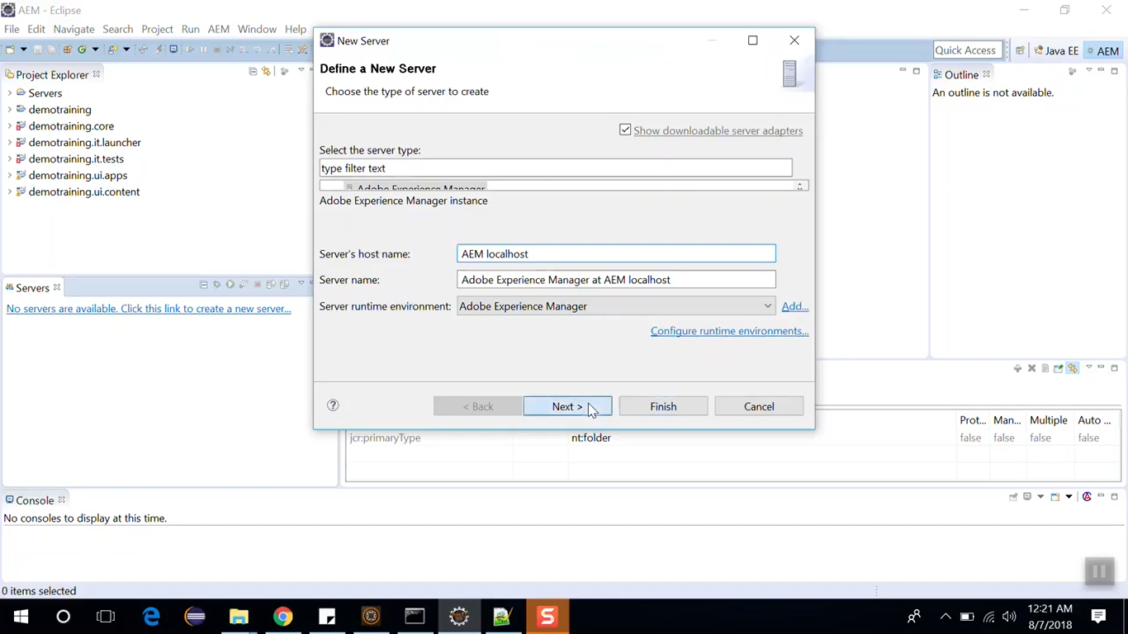 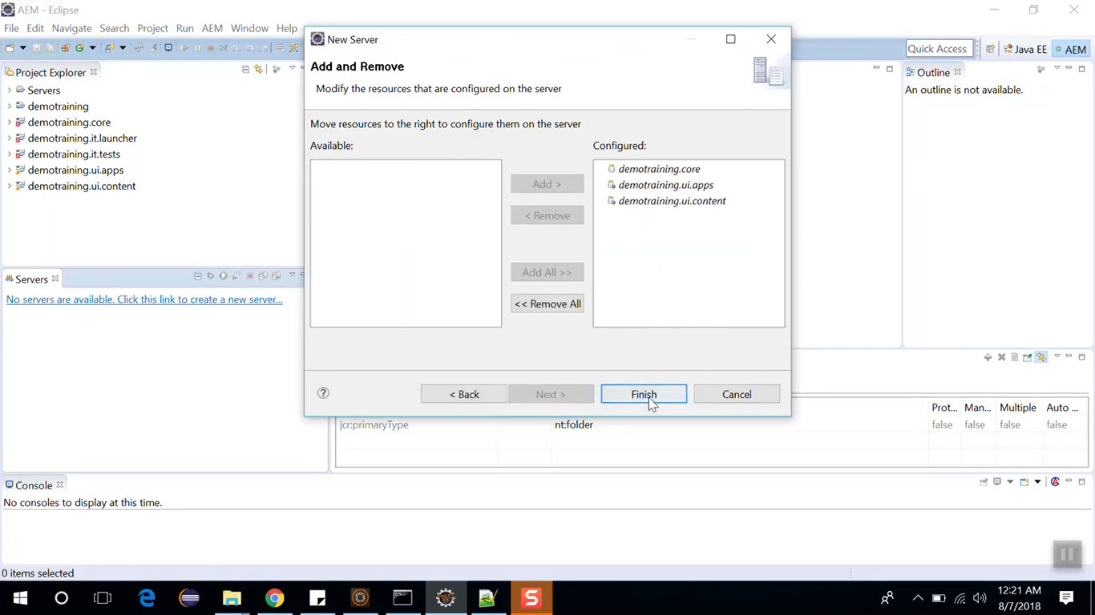

Now double click on newly created server from Servers explorer. It will open Server’s Terminal.

It will show properties to connect with local AEM instance. You will see Port Number (default set to 8080)

Since our AEM instance is running on port 4504, we will change Server’s Port Number from 8080 to 4504.

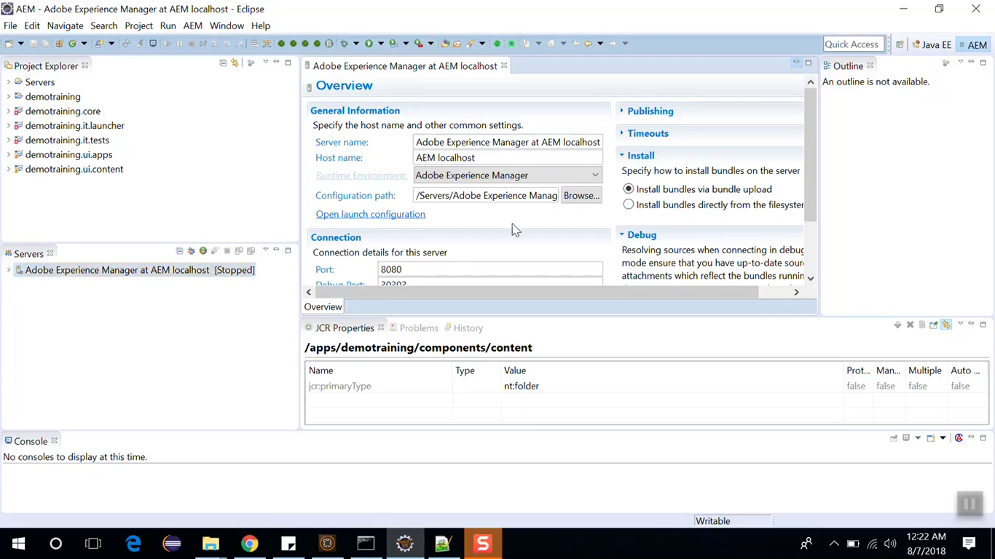

From Publishing section on Server Terminal, select “Never publish automatically”. Click on **Save** button.

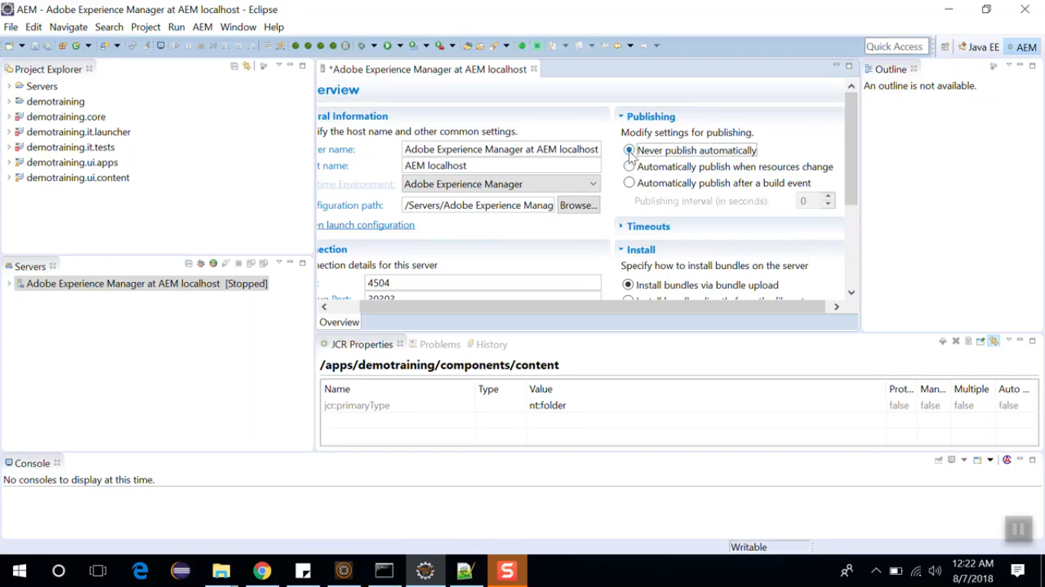

Right Click on the server and **Start** option to start the Server. You will get below error.

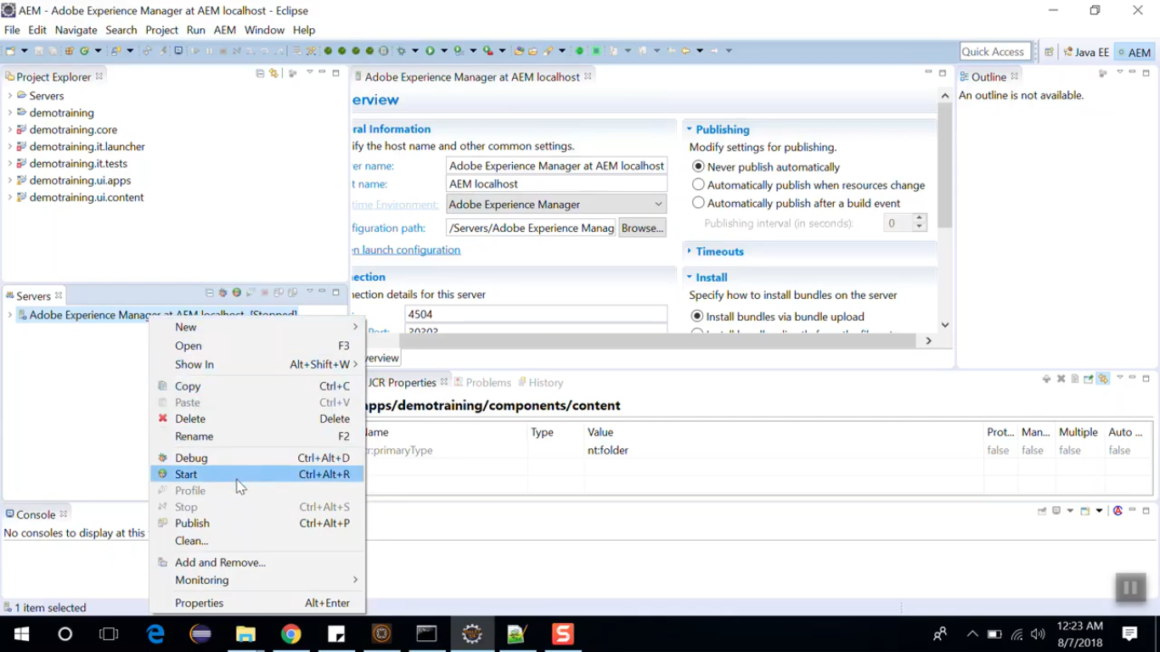 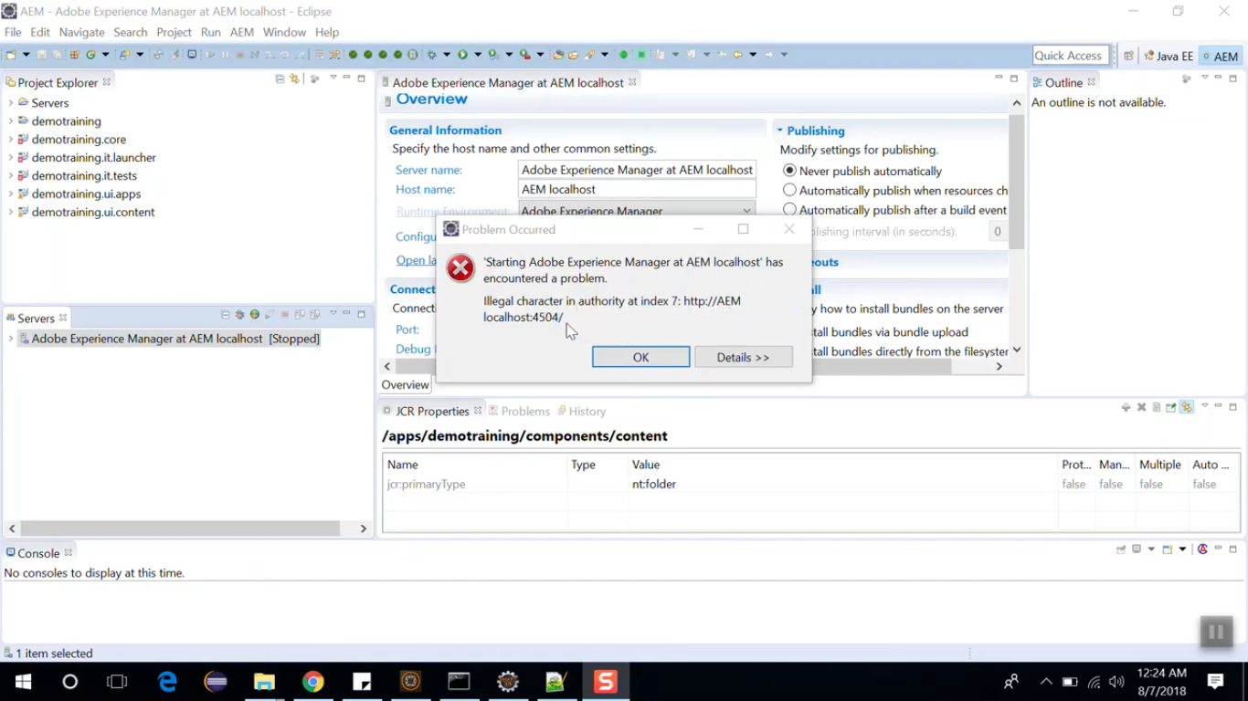

To solve this error, change **host name** from **AEM localhost** to **localhost** in **Server’s Terminal**.

Click on **Save** button. Right Click on the server and **Start** option to start the Server.

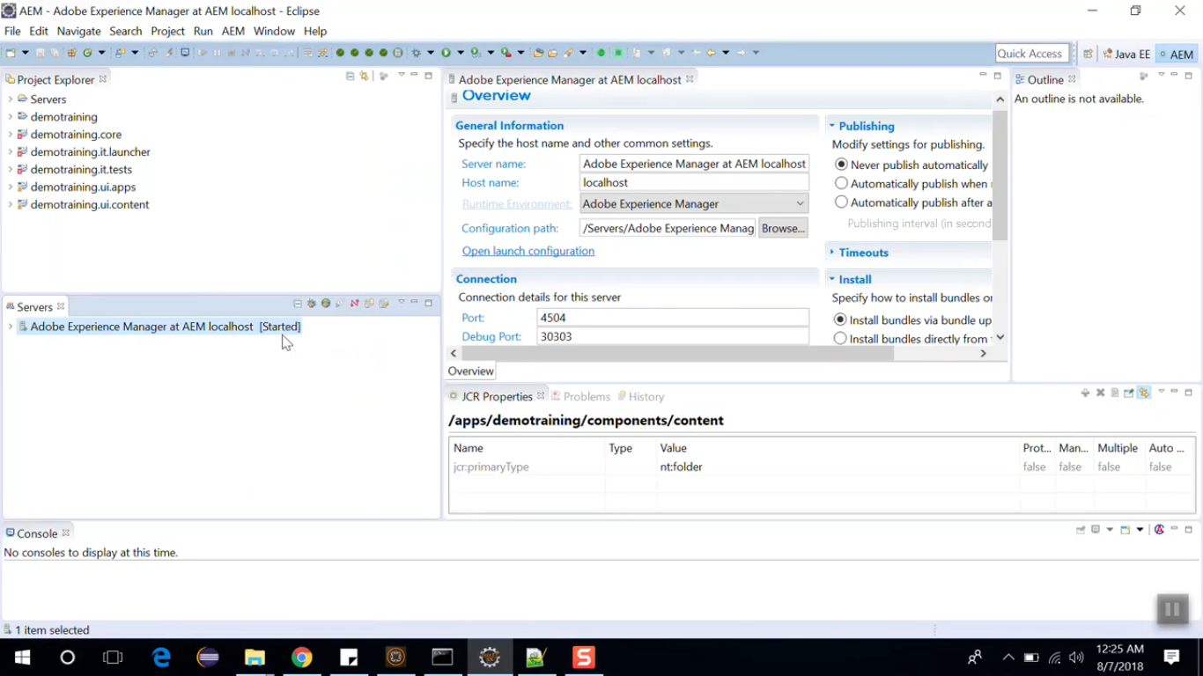

You can change to console from **simple console** to **AEM console**. So that you can see all AEM history.

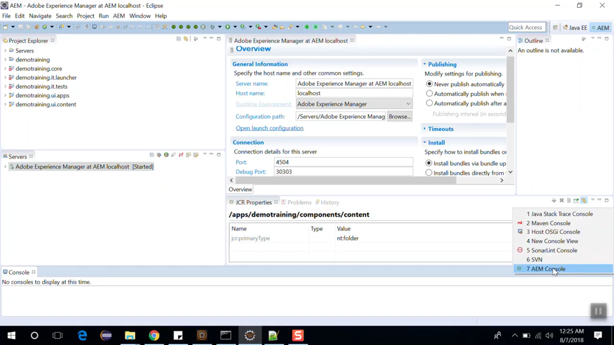

Now let’s create a node. In Project Explorer, right click on node **demotraining.ui.apps/src/main/content/jcr_root/apps/demotraining/components/content**

Select option **New** --> **Node** --> Name it **dummy** --> select node type as cq:Component --> Click **OK** button.

Click on **Save All** button.

Right click on newly created **dummy** node --> select option **Export to Server** --> Click on **Finish** button.

This will **move** our code from **local Eclipse** to **local AEM instance**.

To check this, go to CRX/DE --> **/apps/demotraining/components/content**

You will see **dummy** component node. Add new property for **dummy** node from properties pane.

|  |  |  |
| --- | --- | --- |
| **Name** | **Type** | **Value** |
| jcr:title | String | Dummy component |

Now we will see how to import this change (which we made from CRX/DE) to Eclipse.

Right click on **dummy** node in Eclipse --> select option **Import from server** --> click on **Finish** button.

You can see the newly created property **jcr:title** in JCR properties pane in Eclipse.

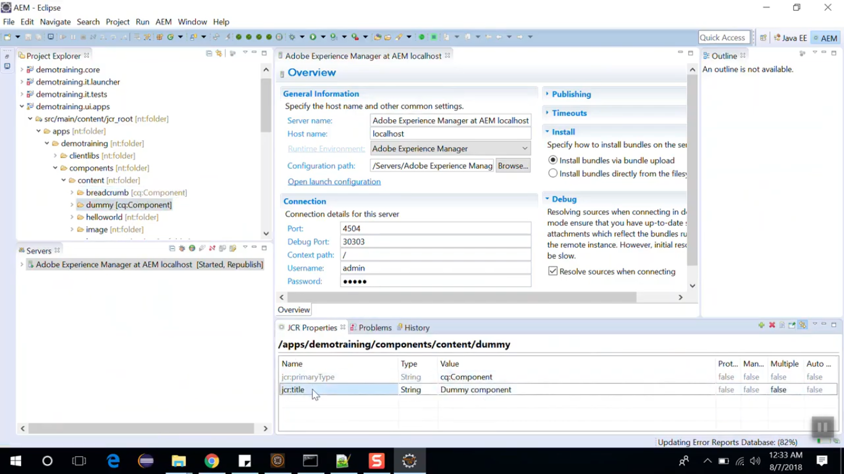

This way you can import changes from **Eclipse** to **local AEM instance** and **local AEM instance** to **Eclipse**.

# 63. Debugging AEM application in Eclipse IDE

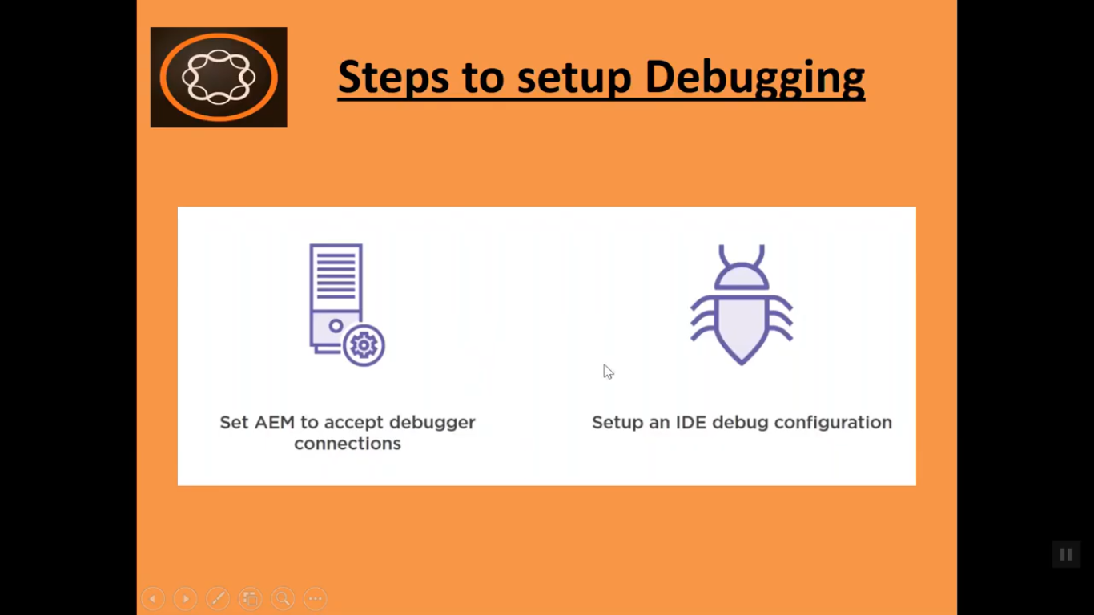

**Set AEM to accept debugger connections:**

We do that by setting some options in JVM that opens up a prot that we can then connect our debugger to.

**Setup an IDE debug configuration:**

We have to go into our debugger and setup our **Debug Configuration** to point to that code that we opened on our AEM instance.

Go to your AEM folder and navigate to path **C:/AEM 6.4/crx-quickstart/bin/start.bat**

Edit **start.bat** file. You will find JVM options at line number 25. Here you need to pass some JVM arguments. Copy below arguments and we need to paste between line number 25.

**Before Code at line number 25:**

If not defined CQ_JVM_OPTS set CQ_JVM_OPTS = -Xmx1024m -XX:MaxPermSize=256M -Djava.awt.headless = true

**After Code at line number 25:**

If not defined CQ_JVM_OPTS set CQ_JVM_OPTS = -Xrunjdwp:transport=dt_socket,server=y,suspend=n,address=3000

Here we are using port number 3000.

Now we have to open our AEM application using this **start.bat** script.

Open command prompt at location **C:/AEM 6.4/crx-quickstart/bin.** Run command **start.bat**

It will start AEM instance and it will be show below message in another command prompt window: **Listenning for transport dt_socket at address: 3000**

Open Eclipse IDE. In project explorer open file **demotraining.core/src/main/java/com.aem.demo.core.models/HelloWorldModel.java**

Put breakpoint at line number 40 and 46.

Now we will setup Debug Configuration. Click on **Run** Menu --> select option **Debug Configurations** --> right click on **Remote Java Application** --> select **New** --> Give below values **--> Apply** and **Debug button**

|  |  |  |
| --- | --- | --- |
| **Field Name** | **Default Value** | **New Value** |
| Name | HelloWorldModel | AEM local debug |
| Project | <blank> | demotraining.core |
| Port | 8000 | 3000 |

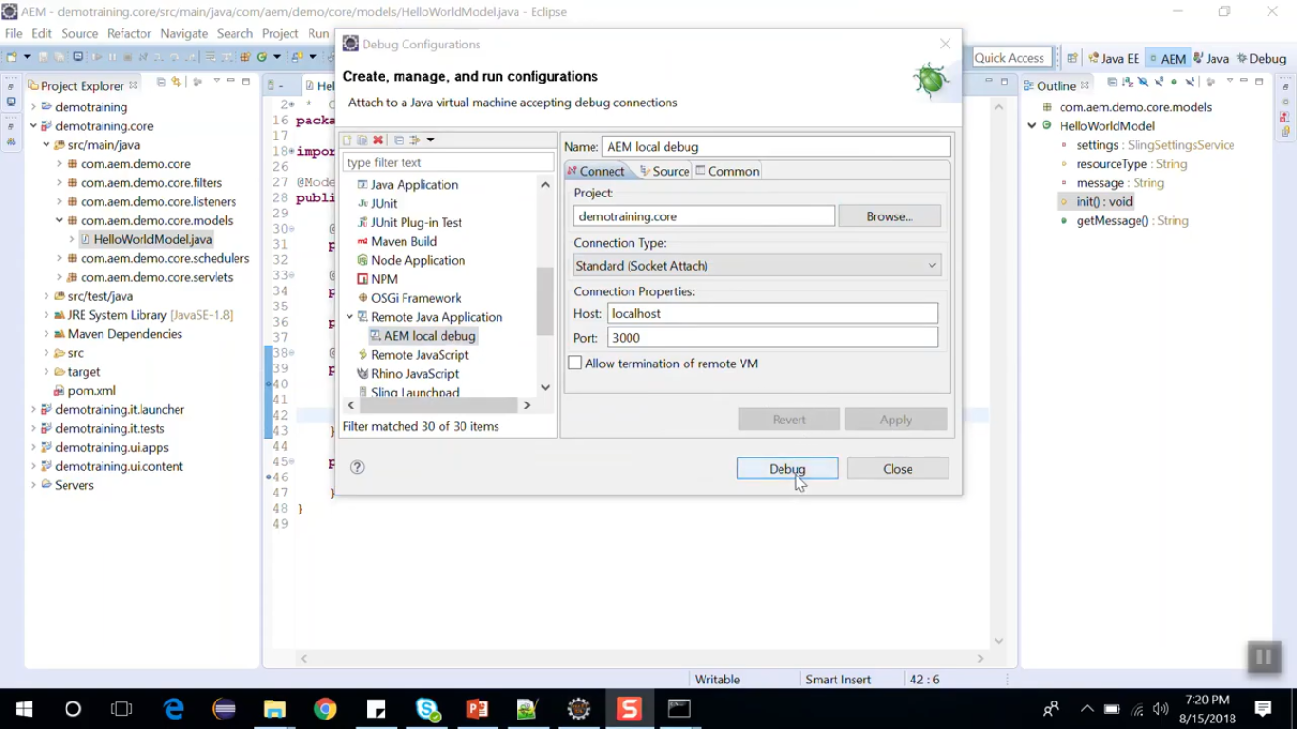

To open debugger console, click on **Window menu** -->select **Show View** -->select **Others** --> select **Debug**

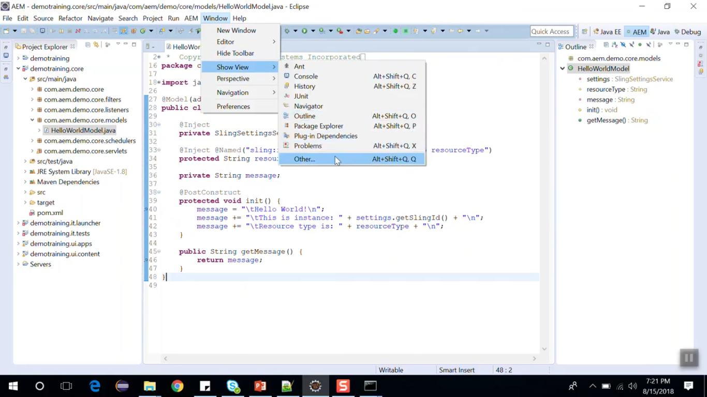 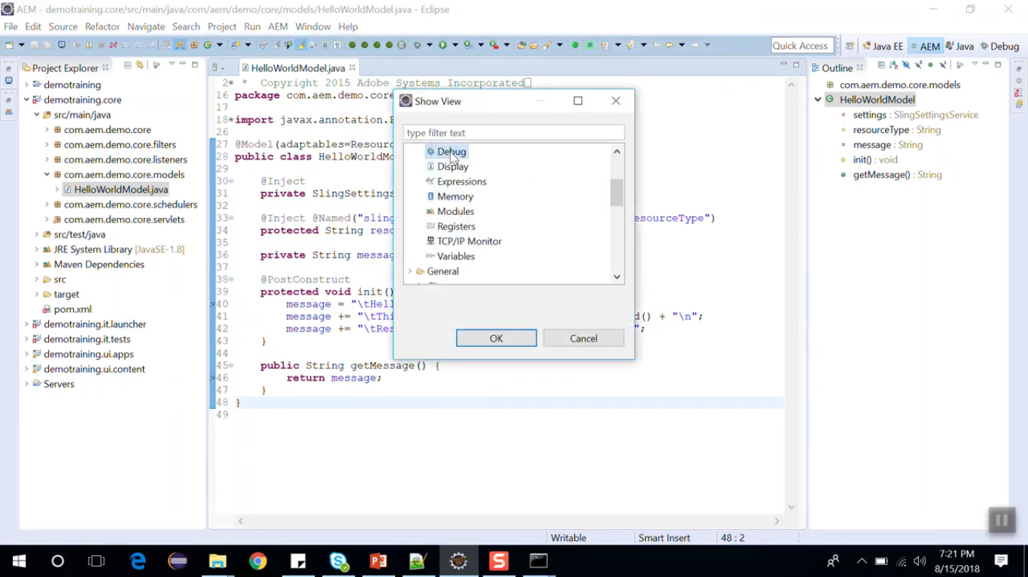

Open English page, it will stop at our breakpoint and that will conclude that it has started debugging.

# 64. Content Fragment

1. This concept of Content Fragment is **introduced in AEM 6.2** version.
2. Content Fragment allows you to design, create and use page in the parent content.
3. Content Fragments are stored as Assets which can be created and maintained from the asset console. Animations that you create from Fragments that are also stored as an Asset.
4. Content Asset which contains text elements and might include other references to other assets.
5. That means text, images, videos and other fragments can be included in the Content Fragment.
6. It is used in the Page Editors by the means of Content Fragment component i.e. referencing component.
7. Comntent Fragment Component is available to Authors and it allows authors to refernce required Content Fragments.
8. Content Fragments can contain registration of Master Elementsto adjust Fragment text according to the specific general requirements and it can have hierarchical structure.
9. These content fragments are defined by fragment template.
10. Let’s talk about use case of the Content Fragment.
11. It can be used to design content variation for specific channels. Example, Article for mobile and desktop.
12. At present content can be authored once templates and components are completed.
13. There was no option to cretea content before it is being authored.
14. So the content author must wait to complete components and templated first.
15. But with the help of Content Fragment author can create content before it is being authored in a page.
16. Content Fragment can be created once and reused many places.
17. Lets talk about compoent of Content Fragment.
18. Content Fragments are made up of
19. Fragment elements --> such as text assets
20. Variations --> which are additions of Fragment Texts which are specific to ediotorial purpose.
21. Fragment paragraph
22. Fragment metadata
23. Associated Content --> It is which is external to fragment
24. Fragment Template --> Which defines structure of the Template
25. Content Fragment Component --> which is responsible for layout and delivery of the Fragment.

# 65. Create Content Fragment and its variation

Go to AEM --> Assets icon --> Files icon --> DemoSite folder --> Create button --> Folder -->

Assign Title field and Name field as content-fragment --> Create button

It will create a folder of content-fragment --> Go inside folder --> Create button --> Content Fragment

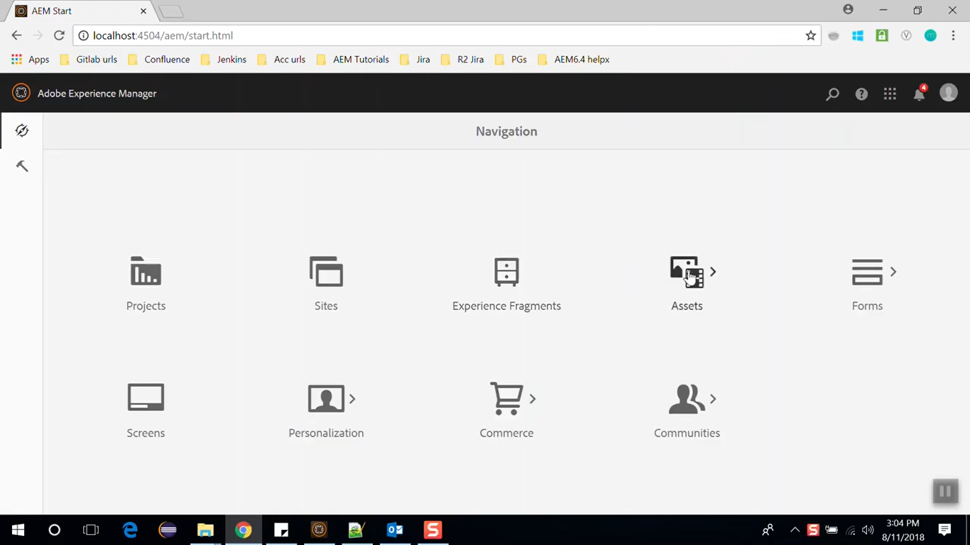

**For Remaining part please watch the video**

# 66. Adding an image in Content Fragment

**Please watch the video**

# 67. Content Fragment Model

2 types of Fragments

Simple Fragments

Fragments that contain structured content

These are based on Content Fragment Model which pre-defines the structure for the Fragments.

Content Fragment Model is introduced in AEM 6.4

Content Fragment Model defines the structure of the content of your Content Fragments.

You can create Content Fragments using Content Fragment Models.

Content Fragment Model work as templates for structured Content Fragments.

**Steps to create Content Fragment Model**

1. Enable content fragment model from Configuration Manager.
2. Apply Configurations to you Assets folder.
3. Create Content Fragment Model.

**Watch the video for Remaining part**

# 68. Dynamic dropdown with DataSource

In technical terms, Data Source is a factory to provide a collection of resource.

Most of the times we use it to provide dynamic items to a container component.

Data Source within dialogs are used in place of the items node structure to represent the items of a container component.

To use Data Source in our dialogs, we must create a node with **datasource** and point the sling:resourceType property to actual data source resource.

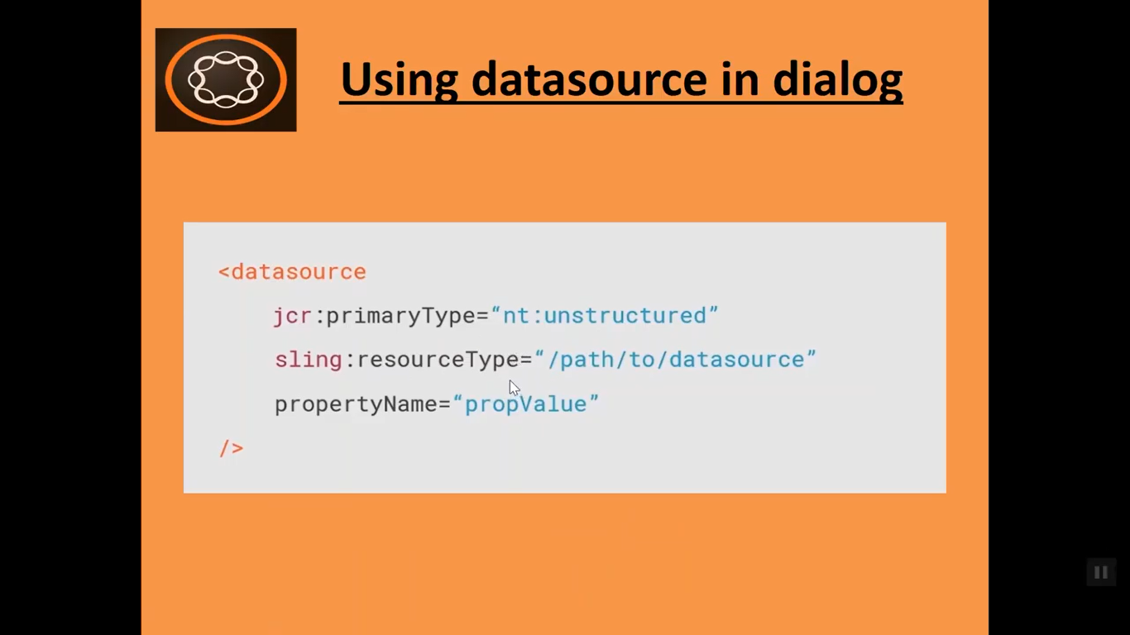

You can manage the Data Source in a dialog and that's using an ACS Commons list (**Generic list** Tool).

Download the ACS Commons package from the link

<https://adobe-consulting-services.github.io/acs-aem-commons>

​

In this section we will learn how to fill dropdown dynamically using Data Source.

Go to <http://locahost:4504/editor.html/content>

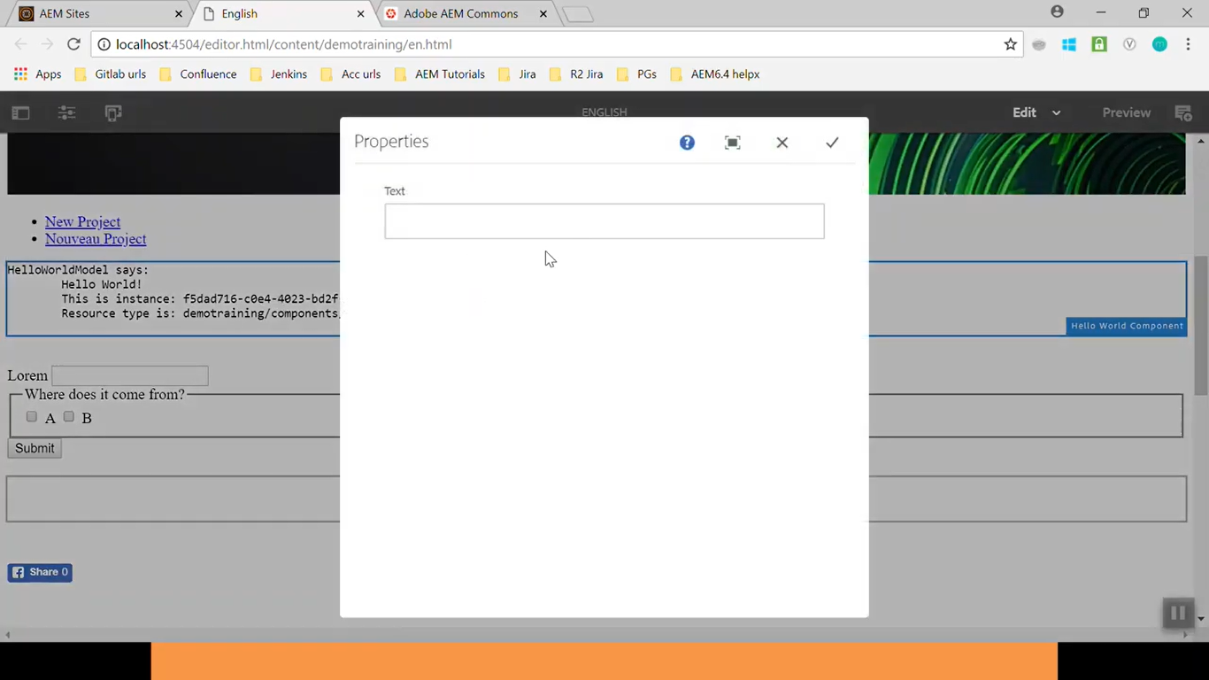

Edit Hello World component to open Dialog box (image above). We will implement dropdown and fill newly created dropdown dynamically using **Data Source**. To manage DataSource of a dialog we will use ACS Commons List. ACS Commons is a open source project that provides a whole suite of useful tools.

Download the ACS Commons package (version 3.17.X) from the link

<https://github.com/Adobe-Consulting-Services/acs-aem-commons/releases>

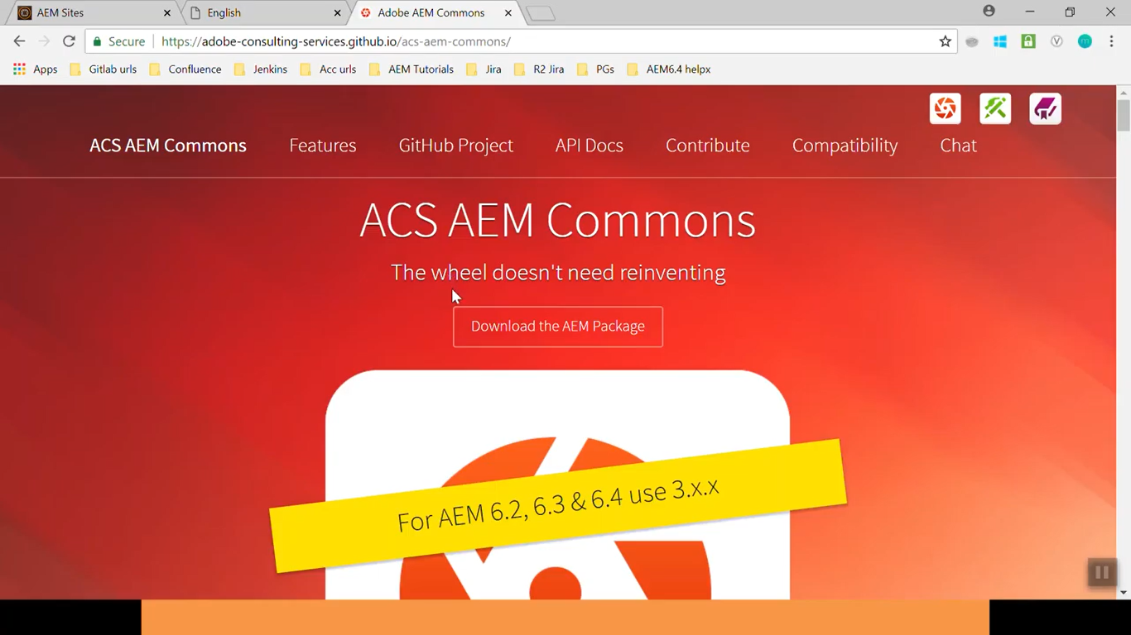

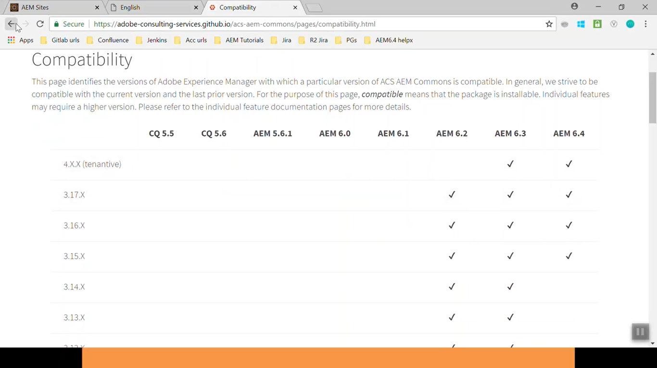

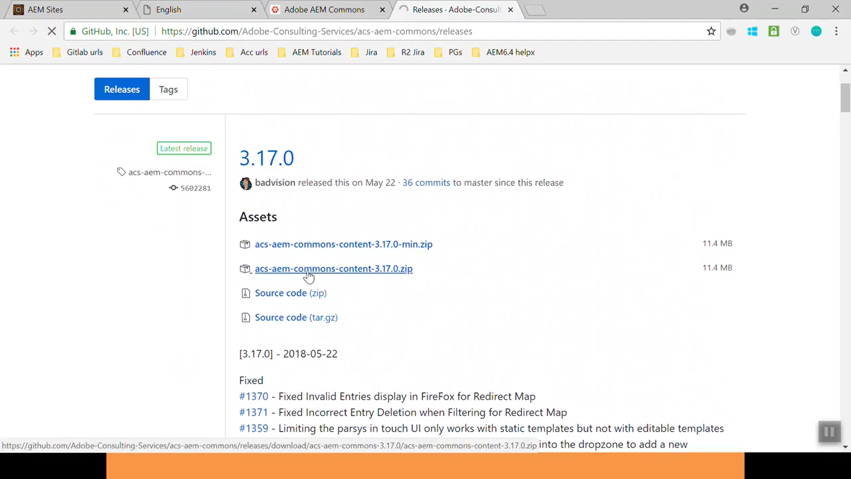

Once download is completed for ACS commons 3.17, go to CRX package manager and upload this package.

Go to <http://locahost:4504/CRX/packmgr> --> Click **Upload Package** button --> select downloaded ZIP --> Click **OK** button --> Click **Install** link (for uploaded package)

Once package is uploaded and installed, go to CRX/DE path **/apps/demotraining/components/content/helloworld/cq:dialog**

Open this **cq:dialog** node till last leaf node. We can see only text field there. We’ll create dropdown here.

Copy the leaf node **text** andpaste there. Rename the copied node to **coutrylist.**

Change property value from properties pane.

|  |  |
| --- | --- |
| **Field Name** | sling:resourceType |
| **Old Value** | granite/ui/components/coral/foundation/form/textfield |
| **New Value** | granite/ui/components/coral/foundation/form/select |

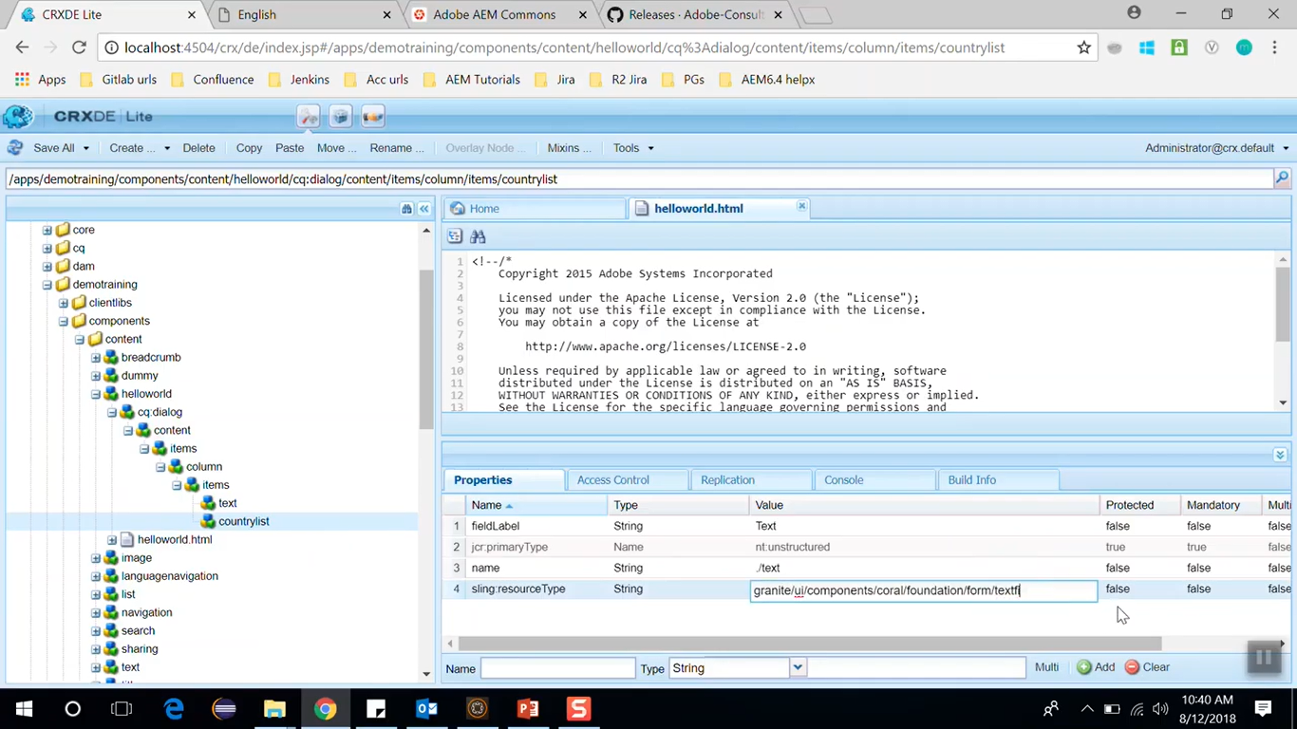

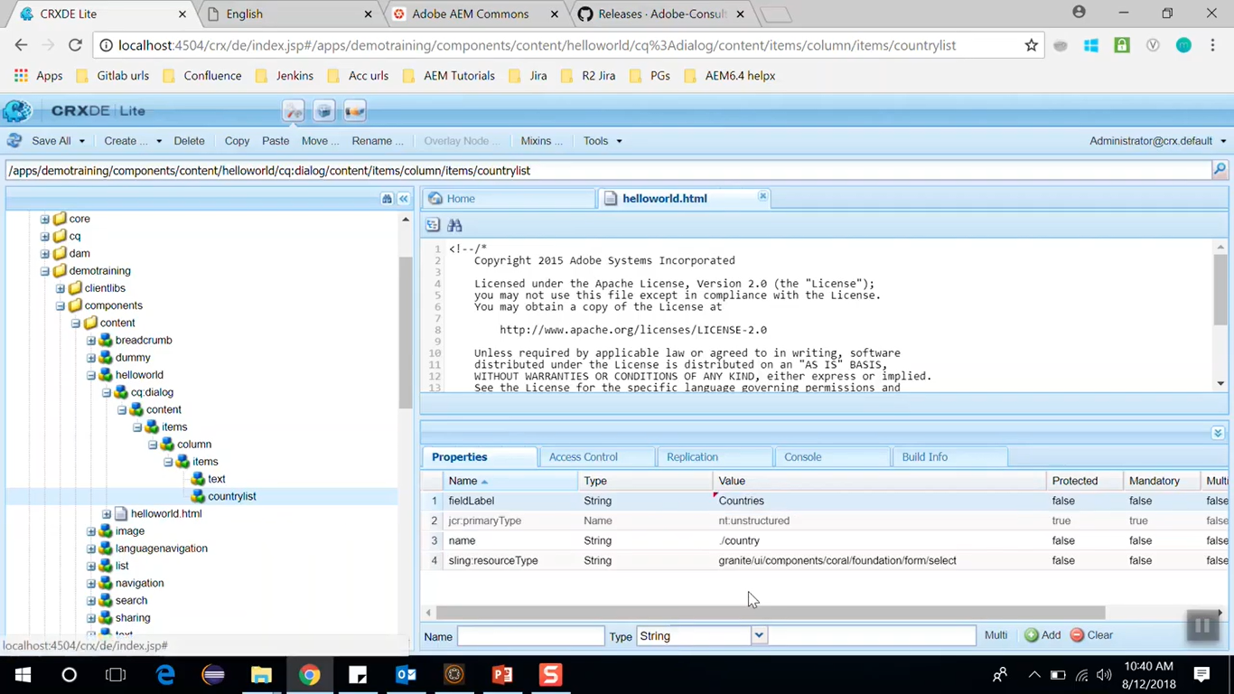

|  |  |
| --- | --- |
| **Field Name** | fieldLabel |
| **Old Value** | Text |
| **New Value** | Countries |

Right click this newly created node **countrylist** --> Create --> Create Node --> Set below values

|  |  |
| --- | --- |
| **Field Name** | **Field Value** |
| Name | datasource |
| Type | nt:unstructured |

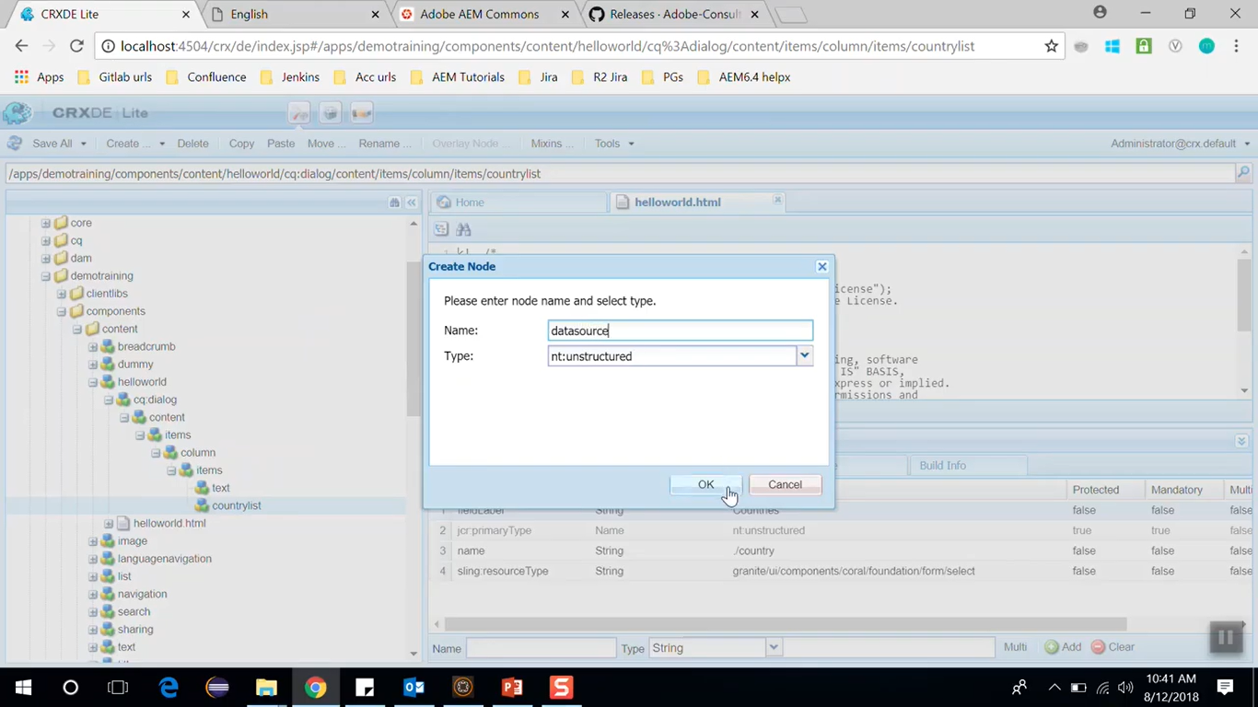

Add below property to newly created node **datasource**:

|  |  |  |
| --- | --- | --- |
| **Property Name** | **Type** | **Value** |
| sling:resourceType | String | /apps/acs-commons/components/utilities/genericlist/datasource |
| path | String | /etc/acs-commons/lists/countrylist (we will create this in below steps ) |

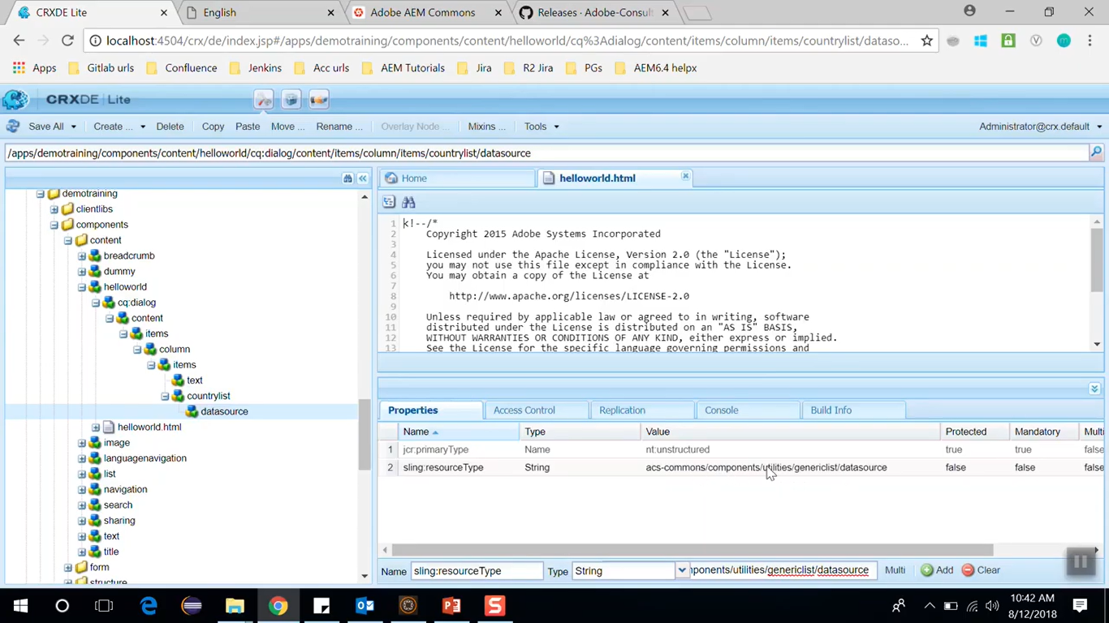

Click **Save All** button

ACS commons provide simple interface for creating list (key value pair). You can find it using below steps.

Go to AEM --> <http://localhost:4504/aem/start.html> --> **(1)** Click on **Tools** icon (left side icon bar) -->

**(2)** Click on **Operations** --> **(3)** Click on **Configurations** (see below images)

This will open **miscadmin** --> http://localhost:4504/miscadmin --> In project explorer (left side) -->

Right click on node **Tools/acs-commons/Generic Lists -->** Click on **New** button (from Toolbar on top) -->

On Create Page dialog set page **Title** value to **countrylist** -> Click on **Create** button -> Click this newly created page node **countrylist** to open page <http://localhost:4504/etc/acs-commons/lists/countrylist.html>

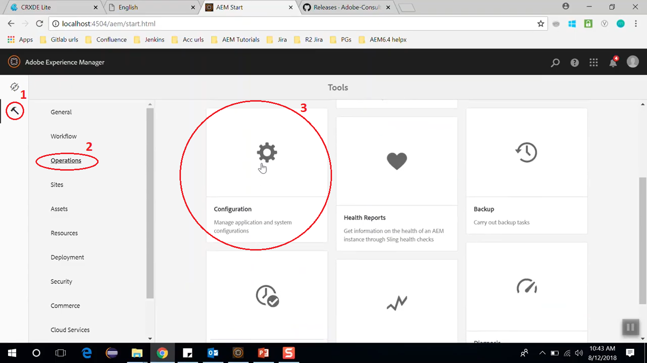

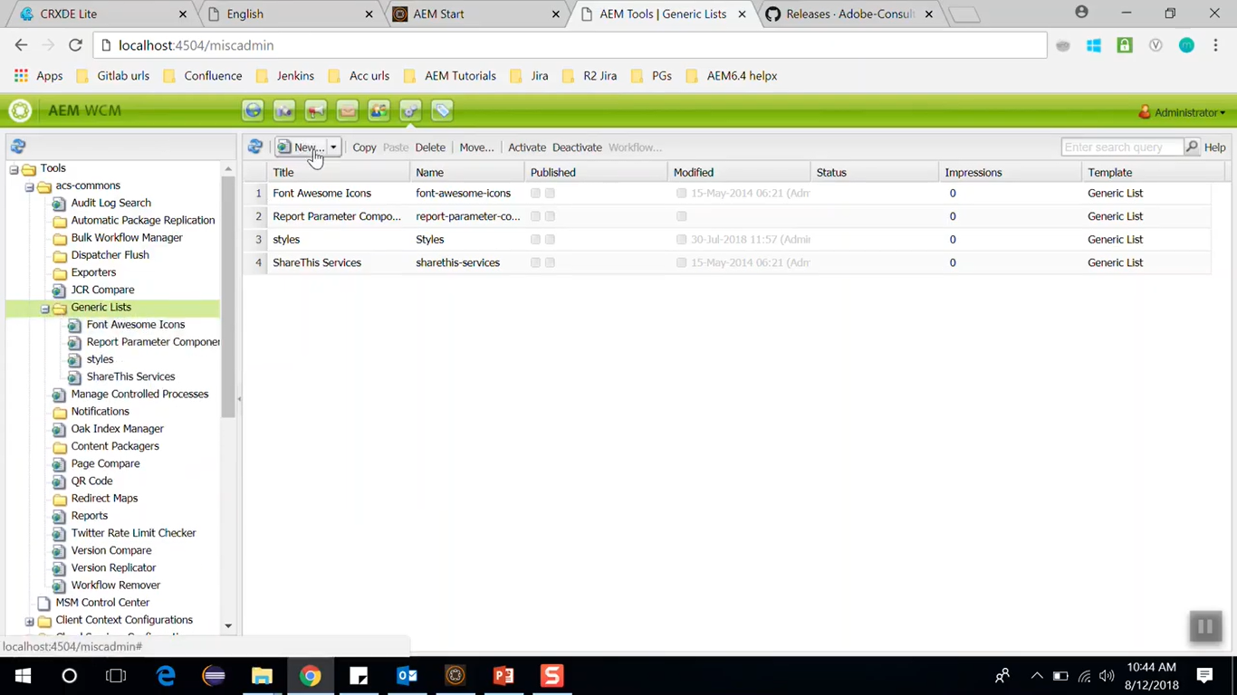

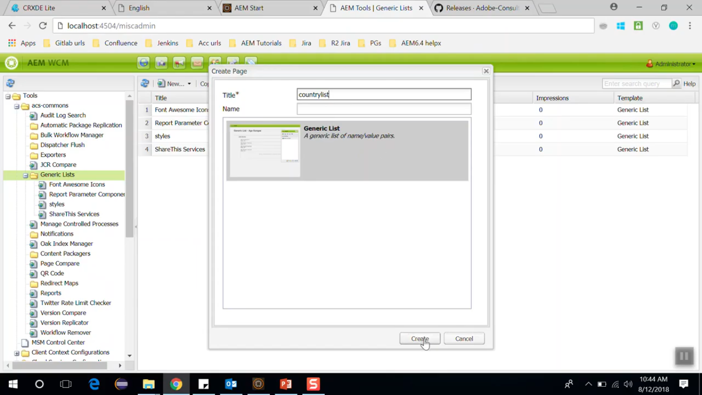

Drag and Drop component **Generic List Item** to List Items components area on the page (image below)

Repeat it 2 more times as we need 3 countries. Click on each added component to enter key value pair.

|  |  |  |  |
| --- | --- | --- | --- |
| Title | Ind | USA | Ca |
| Value | India | America | Canada |

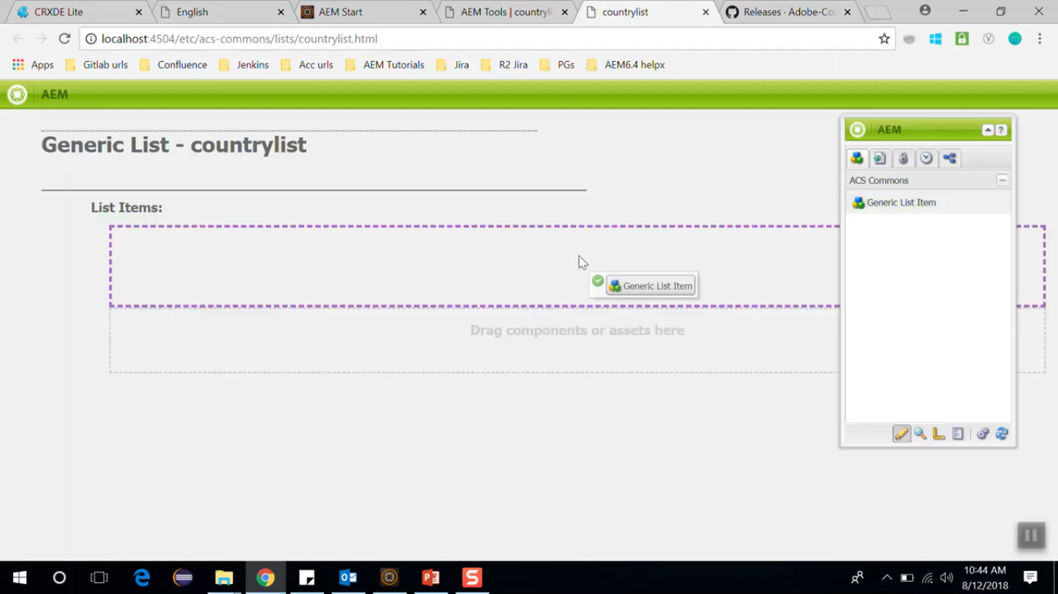

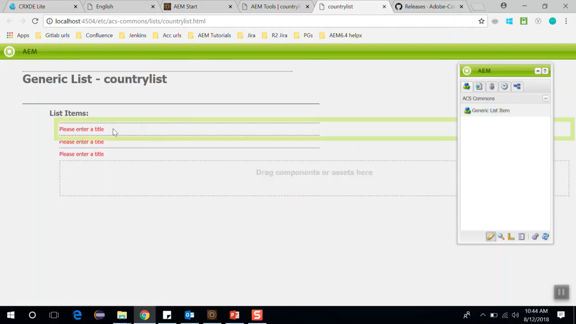

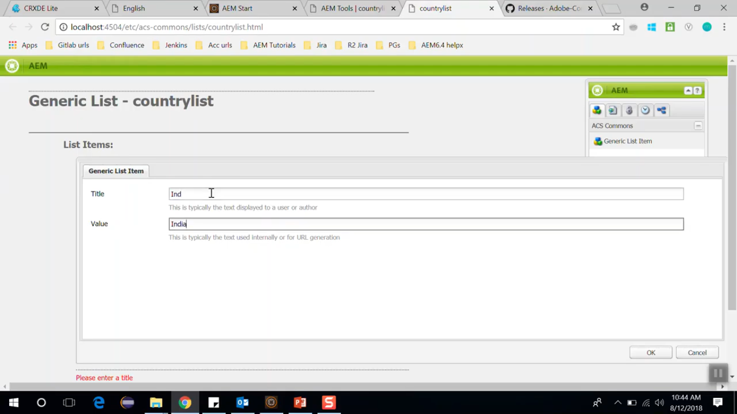

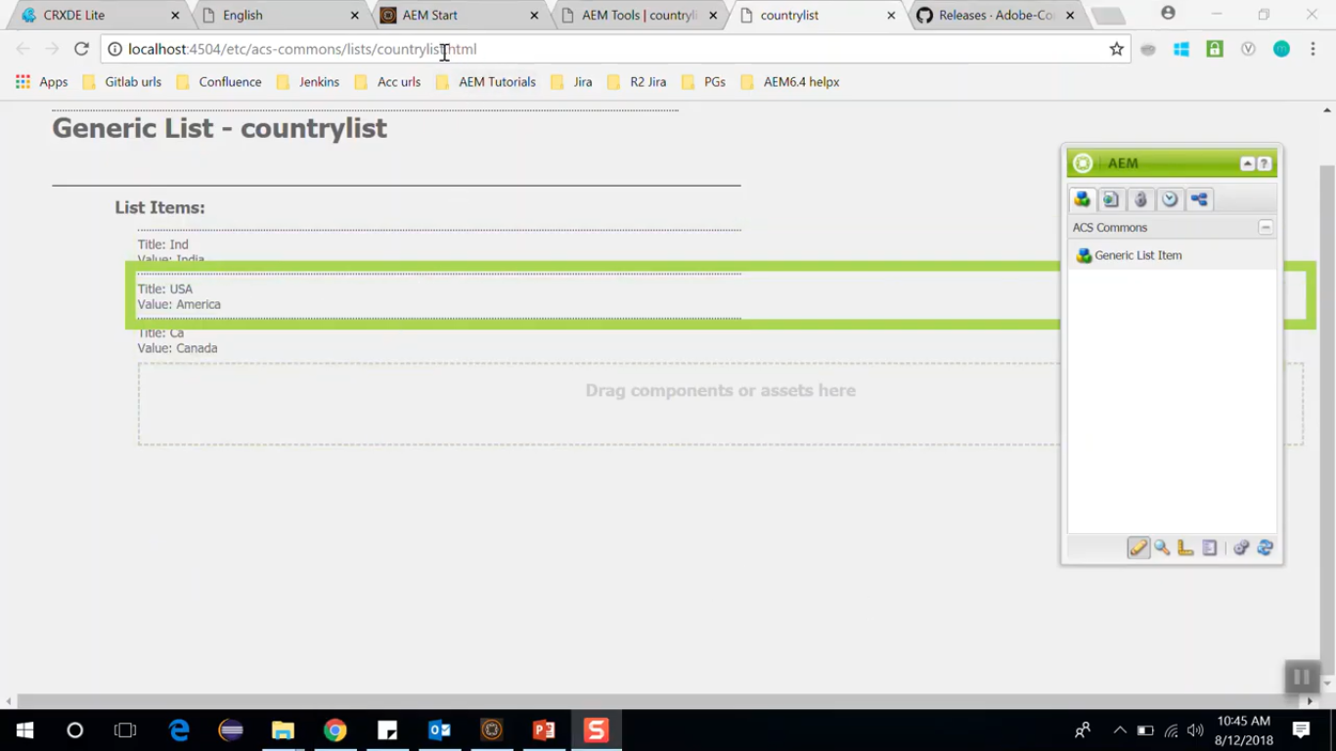

Copy the **highlighted path** of this page <http://localhost:4504/etc/acs-commons/lists/countrylist.html>

This is the path which we have to set to a property named path of the **datasource** node which we created in earlier step.

|  |  |  |
| --- | --- | --- |
| **Property Name** | **Type** | **Value** |
| path | String | /etc/acs-commons/lists/countrylist |

Go to CRX/DE. Open file from **/apps/demotraining/component/content/helloworld/helloworld.html**

Append below code to end of this file

Country: ${properties.country} (see cursor pointer in below image)

Click on **Save All** button

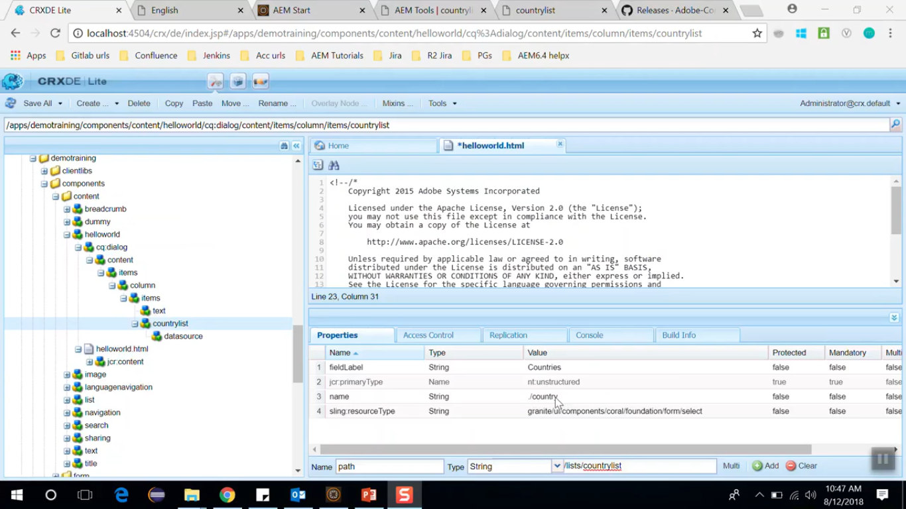

Go to English page <http://localhost:4504/editor.html/content/demotraining/en.html>

Refresh the page. Double Click on Hello World component open dialog box to edit it.

You can see in below image that dialog box is now showing **dropdown list** for **Countries** field.

Consider you have selected **USA** from dropdown and click on OK icon to save changes.

You can see the changes in below image.

If author wants to add more countries in dropdown then he can do so from countrylist generic list.

